

Study tour assessment and analysis on the supply chain and recommendations for facilitating a single window system for imports and exports

Robert L. Wallack
Dr. Enkhbold Vorshilov

August 24, 2016
The European Union’s Economic Governance for
Equitable Growth (EG4EG) Project
For Mongolia
This project is funded by
The European Union
(DCI-ASIE/2015/356-018)
A project implemented by the
Deutsche Gesellschaft für
Internationale Zusammenarbeit (GIZ) GmbH



1. Executive Summary 3
2. Introduction: Assessment and Analysis 3
3. Execution: Meetings, Interviews and Workshop 10
4. Cost analysis of Mongolian export goods 19
5. Recommendations & Mission Examples to Benefit from Single Window 24
Annex 28

List of annex:
Annex 1: Sample Manual of the Mongolia National Single Electronic Window Master Plan
Annex 2: Meetings’ documentation
Annex 3: Workshop documentation

Executive Summary

What this report is about

The aim of this report is to assess Mongolia’s trade facilitation arrangements with
updated data, information and performance over the past five years on importing and exporting goods along the road and rail corridor from Ulaanbaatar through Zamyn-Uud to Erlian, Inner Mongolia, PR China border crossing to the Tianjin seaport in order to highlight the benefits to all stakeholders of the importance of Mongolia implementing the single electronic window project. As a result, a number of recommendations are made for the Ministries of Industry, Foreign Relations and Customs General and Ulaanbaatar Customs and for businesses to consider to improve supply chains and trade competitiveness for access to global markets of Mongolia’s value added products and services. This mission occurred from July 18-August 9, 2016 in Ulaanbaatar, Zamyn- Uud, Erlian, Inner Mongolia, PRC.

In 2011, the Mongolian Customs General Administration with the Mongolia National Chamber of Commerce and Industry drafted a “Master Plan for the Mongolia National Single Window” with support from the United Nations Economic and Social Commission for the Asia Pacific (UNESCAP). The single window system is currently deployed in developed and developing countries for traders interacting with government agencies over a single-point web portal for electronic entry of trade related documents, such as customs declarations, licenses, permits, manifests and invoices. The financial constraints to implement this project appear to be lifted by a June, 2016 $29.07 million loan proposal from the Asian Development Bank and approved by the Government of Mongolia (GOM): Regional Improvement of Border Services Project.

This report will highlight important issues discovered during the sixteen meetings with business and government officials on the “study tour and supply chain analysis” in Ulaanbaatar, Zamyn Uud and Erlian, China as well as from the August 9th workshop in Ulaanbaatar. The basic diagnosis which results from this analysis, is this: a long term national inter-ministerial and agencies’ committee with working groups is essential to a successful implementation of the single window project containing both government and business officials and not disbanded when government changes.

Trade can be facilitated by a single window project and will bring management of trade and transport costs and reduce delays along the road and rail corridor, more profits for private enterprises, more revenues for government and increased domestic and foreign investments. This basic diagnosis does not mean that other issues are less important to improving Mongolia’s international trade competitiveness. This study will also make legal (policy) and technical recommendations with some concrete examples from the mission to show how companies and government agencies will benefit immediately, from the single window implementation.

Introduction: Assessment and Analysis

Mongolia’s development and private sector involvement will measurably improve by diversifying its economy across many sectors and not dependent on the mining sector. In support of that diversification, trade facilitation and management of trade and transport costs and delays are paramount. Lowering tariffs, free trade agreements and membership in the World Trade Organization (WTO) are not enough to improve Mongolia’s international trade and investments. Operational and infrastructure issues are causing delays and adding costs for businesses. In fact, the WTO reports that full implementation of their Trade Facilitation Agreement (TFA) could reduce WTO members’ trade costs by an average of 14.3 percent including 18 percent for manufactured goods and 10.4 percent for agriculture products. The report further states that goods exports could rise by up to $1 trillion per year of which $730 billion in developing countries and create 20-30 million new jobs. Perishable agriculture goods and intermediate manufactured goods are likely to see the biggest boost. Developed and developing economies are embracing new technologies and Web-based software applications that move from paper to paperless or automated business processes by Internet connections for traders, Customs and government agencies. Mongolia is poised to deepen their information technology environment.

Since 2011, the economy of Mongolia suffered from the global financial crisis and moreover, lower demand and prices for natural resource commodities of which Mongolia grew dependent. Exports are heavily concentrated on mineral products. The share of these products in merchandise exports rose from 40.7 percent in 2004 to 89.2 percent in 2012 before falling to 78.8 percent in 2015, according to ADB. GDP is still dropping in percentage terms from 12.3 in 2012 to 11.6 in 2013 to 7.9 in 2014 to 2.3 in 2015. These negative economic indicators are also causing lower foreign direct investments and a draw down on the foreign exchange reserves.

International trade data shows growth. Between 2010 and 2014, imports and exports nearly doubled, with exports increasing from about $2.9 billion to $5.7 billion and imports from $3.2 billion to $5.2 billion. Clearly much more can be accomplished by improving Mongolia’s trade facilitation to control costs and delays and boost exports.

Table 1: Foreign Trade Turnover ($million)
Item | 2010 | 2011 | 2012 | 2013 | 2014 | 2015
Total Turnover | 6,109 | 11,416 | 11,123 | 10,627 | 11,011 | 8,467
Export | 2,909 | 4,818 | 4,385 | 4,269 | 5,775 | 4,670
Import | 3,200 | 6,598 | 6,738 | 6,358 | 5,237 | 3,797
Balance | (292) | (1,781) | (2,354) | 2,089 | 538 | 872
( )=negative
Source: Central Bank of Mongolia, Statistics of Mongolia Customs General Administration, National Statistics Office

Mongolia is also dependent on the People’s Republic of China (PRC) and the Russian Federation as the main trading partner countries for imports and exports, consistently since 2007. In 2014, the total trade with these two countries was 77 percent (62% and 15%, respectively) with the PRC receiving about 90% of Mongolia’s mineral exports and 34% of total imports originating from the PRC. The main exports to the PRC are: coal, iron ore, copper and molybdenum concentrates, wool, cashmere, hides and skins. The European Union is the next highest trading partner with 9 percent of the total of which gold, textile and cashmere goods are exported.

Lower economic growth and trade is evident in one interview on this study tour with a Mongolian logistics service provider stating lower volumes and lack of demand for their services, this year. The Ministry of Industry (Food, Agriculture and Light Industry) are advancing policies to improve business conditions for domestic and export production to offset the reliance on one sector. In fact, food and agriculture sector contributed 13.1 percent of gross domestic product (GDP) in 2015 (manufacturing was 8.4 percent), according to ADB, and about one third of the total labor force, whereas mining contributed about 24.7 percent of GDP and employs only 4 percent of the total labor force.

Value added products and services will become more cost competitive in landlocked Mongolia with better trade facilitation measures, namely implementing the single electronic window platform project since high trade costs are attributed to too many documents, inadequate infrastructure on the borders and not enough cross border PRC cooperation. “Wool and cashmere sector is a major export sector of the total value of cashmere, 85 percent is exported or scoured, 12 percent is exported as carded/combed and only 3 percent is exported as end products. Value addition in this sector will increase export earnings to 1 trillion Mongolian tugrugs (MNT/ $500 million), according to the Ministry of Industry.”

The meat sector presents other profitable opportunities for enterprises, but not without improved trade and transport facilitation (refrigerated equipment) along the transport corridors, at the borders for third country market entries. “There are 41 legitimate meat producers across Mongolia exporting meat to the Russian Federation, Vietnam, and effective this year signed an agreement with China to supply $1 billion worth of meat. Last year, Parliament Resolution 75 created the ‘Khalkh Gol’ Free Trade Zone in Dornod province of eastern Mongolia. The FTZ covers 500,000 hectares and promises to establish 2,200 workplaces in addition to farming, agriculture, logistical and tourist activities that will yield about 141 billion MNT ($70,500,000), annually.”
In addition, total trade over gross national product since 2010 was about 115% on average, although it declined from 130% in 2004 to 100% in 2014. Poor trade facilitation significantly reduces Mongolia’s competitiveness in global markets. Improving connectivity and cross-border cooperation will therefore help lower these costs.

The World Bank Logistics Performance Index (LPI) and Trading Across Borders (Doing Business) reports are instructive to analyze Mongolia’s performance and position on the global stage where there is fierce competition for investments both domestic and foreign. In fact, multinationals and small and medium enterprises view these two reports in deciding where to build a new refrigerated warehouse, for example.

In Table 2, Mongolia’s rank in the LPI out of 160 countries improved from 2010 to 2016 more than neighboring China and Russia. The LPI indicators are based on: customs clearance, quality of infrastructure, ease of pricing shipments, logistics competence, track and trace, and timeliness which points to an indicator measured weekly by companies: on time delivery (OTD). The implementation and the full use of the Single Window in Mongolia will bring more attention to the importance of metrics to measure performance (managing costs and time) in trade logistics for both the nation and enterprises. As a result, Mongolia will begin to lower its logistics costs as a percentage of GDP from 28 percent as compared to in the United States of 8.5% of GDP.

Table 2: Logistics Performance Index
 | 2016 rank/160 | 2014 | 2012 | 2010
Mongolia | 108 | 135 | 140 | 141
PR China | 27 | 28 | 26 | 27
Russia | 99 | 90 | 96 | 94
Source: 2016-2010 World Bank LPI

In Table 3, the two areas where Mongolia will benefit from automating of processes are seen by the time it takes to process export documents of 115 hours and time to process import documents also 115 hours. These indicators are based on 15 documents such as customs declaration, country of origin (COO) and invoices of which Mongolia’s Customs Administration Information System (CAIS) are electronic, but need further enhancements and moreover, connectivity to other or partner government agencies. As compared to other East Asia and Organization of European Cooperation and Development (OECD) countries, Mongolia has room for much improvement which is possible with the Single Window implementation.

Table 3: Trading Across Borders: Doing Business
 | Mongolia | East Asia | OECD high income
Time to Export Borders(hrs) | 37 | 51 | 15
Cost to Export (USD) | 41 | 396 | 160
Time to Export documents(hrs) | 115 | 75 | 5
Cost to Export documents (USD) | 64 | 167 | 36
Time to Import (hrs) | 22 | 59 | 9
Cost to Import (USD) | 60 | 421 | 123
Time to Import documents (hrs) | 115 | 70 | 4
Cost to Import documents (USD) | 83 | 148 | 25
Source: 2016 Doing Business Report, World Bank. Mongolia ranked 74th out of 189 countries.

The Asian Development Bank Regional Improvement of Border Services Project finds that the impact will be increased trade and competitiveness as a result of faster and cost-effective cross-border services. The intended project outcome is reduced cost and time of compliance with trade procedures. In addition, the performance indicators with targets and baselines show that by 2026 or earlier the time and cost to cross project border crossing points will reduce by 30% (2014 baseline) for Zamyn-Uud: 8.7 hours and $383 and time to prepare and process export and import documents reduced by 50% in Mongolia by 2025 based on the above 37 hours for export and 22 hours for import.

Further improvements of logistics services in Zamyn-Uud will be begin in 2018 after the completion of the ADB project for a new Logistics Center facility. This project will be a road and rail transshipment center to overcome the delays in Mongolia from the rail gauge changeover between the wide Mongolia/Russia rail and the narrow PRC rail. According to ADB reports, the Logistics Center will be based on designs that incorporate global best practices for intermodal logistics including integrated management information systems, cargo handling technologies, and storage (e.g.,
utilities and plugs for refrigerated containers) in marked contrast to current facilities that
are inadequate in terms of size, technologies and operating processes. By utilizing
these global best practices, Mongolia will be demonstrating its commitment to upgrade its transport infrastructure and logistics.

The ADB Corridor Performance Measurement and Monitoring (CPMM) report provides more useful indicators of improvements to Mongolia’s trade facilitation and supply chain import/export performance as part of the Central Asia Regional Economic Cooperation (CAREC) program. This report measures Zamyn-Uud and Erlian cross border time, costs incurred, and speed along the corridor. Zamyn-Uud-Erlian is designated as corridor 4b in the CAREC program. The 2015 CPMM report shows some improvements for this rail and road access for Mongolia’s imports and exports to and from Tianjin port.

Road transport enjoyed a 9.3% reduction in total cost over the past year. Speed without delays went up to 36 kilometers per hour (kph), a significant improvement compared to the times recorded before the Zamyn Uud-Choyr (ADB project) road was completed where speeds averaged only 20-30 kph. The Mongolian and PRC Customs administrations are working on joint initiatives in select borders and progressing towards using electronic unified cargo manifests and the simplification of border crossing procedures (this mission revealed these facts)which now require fewer documents. All of these changes resulted in the fall in average border crossing times in both Erlian and Zamyn Uud. Unfortunately, problems remain for rail transport. A train moving from Erlian to Zamyn Uud averaged 26.8 hours and 24.6 hours at each station, respectively. A major cause in time delays is the dwell time in Tianjin seaport for Mongolian bound containers. More details of this issue are in the UBTZ interview on this mission.

Table 4 illustrates the importance of seamless import processing of new mining vehicles and new parts shipments and their documents from Tianjin seaport to the border crossing for on time deliveries to warehouses and mining sites. Moreover, the single window implementation will improve the timely processing of emergency parts needing country of origin documents in case a mining site vehicle in Oyu Tolgoi, for example has an emergency breakdown that stops production. Wagner Asia Equipment sources (purchases) these items from Caterpillar Asia and worldwide. More details can be found in the Recommendation section of this report.

Table 4: Wagner Asia Equipment: Mongolia Imports 2013-16
2013 vehicles 152 items. Cost: $64,974,395.63
2014 vehicles 56 line items. Cost: $16,887,594.40
2015 parts 12,218 line items. Cost: $42,060,762.8
2016 parts 6,845 line items: Cost: $18,584,638.06
_____________________________________________
$142, 507,390.89

Furthermore, the PRC acceded to the TIR conventions of which Mongolia is already a member. This will further boost cross border trade logistics productivity to enhance Mongolia’s trade competitiveness. “The Secretary-General of the United Nations informed that the PRC deposited its instruments of accession to the TIR Convention, 1975, on July 5, 2016. The Convention will enter into force for China on January 5, 2017. The TIR transit system is the only global intermodal customs transit system, constituting a major facilitation tool for both transport and trade.” This will improve economic growth for Mongolia and European Union countries and facilitate trade for transit and logistics services.

Another useful indicator of improving cross border trade conditions are that average border crossing fees dropped on corridor 4b from $267 to $151. Interviews with logistics service providers on this mission also proved this. However, “unofficial fees” are still a problem and the automation of processes by the Single Window project will reduce situations of face to face contact where these fees are likely to occur.

Automating processes will benefit Mongolia’s supply chains and work to reduce unnecessary costs from duplication of documents for imports and exports. The following analysis illustrates the return on investment of a United States business automating 100 transactions per month:
- Cost of manually handling each transaction is $50.
- After implementing automation (electronic data interchange) cost is $5.
- Initial implementation costs are $10,000 for business’s 100 purchase orders/m.
- Cost savings by phased implementation month to month are $60,000 per year
- Manual cost goes from $5000 per month to zero by month 10. Automation cost goes from $10,050 per month to $500 per month by month 10

Mongolia’s approving of the border services project will ultimately open up new revenue streams and job opportunities for logistics and software service providers to take out costs and delays in the supply chain and add value to services which offer higher paying work. One such service could be moving from bar codes to radio frequency identification tags (RFID) for more accurate inventory calculations. Moreover, the collaboration among business and government will provide more databases and web-based applications for better landed cost analysis.

Landed cost analysis has variable costs and the possibility for negotiating costs involving shipping a product from origin to the customer door such as those described under INCOTERMS. Some of the variables are: price of goods, choice of INCOTERMS: risks between buyer and seller; buying agents, consolidation, transportation, duty/tax, insurance, Customs, storage, inland freight, demurrage. In fact, the World Bank estimated in 2014 that automating customs processes can save about $115 per container. A landed cost analysis calculator can be found on a Google search.

One of the issues discussed in the workshop concerned the government cutting jobs either from automation or from the change of governments and also the need to retain government employees after trained in the job. The new government will have 13 ministries and two from the previous administration are eliminated of which the Ministry of Industry is combined with Food, Agriculture and Light Industry. The new government will also have 10 regulatory and 17 implementing agencies and will again separate General Taxation Department and General Customs Authority. Moreover, 1,238 civil servants will lose their jobs and 360 new work places will be created. A consistent and predictable government structure is very important for the continuity of the national inter-ministerial and agencies’ committee whose members are government and business officials responsible for the working groups and implementing the single window project.

There is no simple solution to the government employee issue in Mongolia, but civil service administrations in other countries can offer some guidance and further research.
The United Kingdom (UK) solution works well for them and in the countries of the British Commonwealth (the old British Empire) and some European Union (EU) countries - but not anywhere else. It results from a reform in the 19th century that created a professional Civil Service, highly trained, highly paid and with a guarantee of continued employment. It is separated from political interference, so the staff does not change when the government changes. The only political appointments are the Minister and his personal advisors. Staff appointments and positions are managed by a Civil Service Commission so the individual Ministers cannot appoint or change their staff. The only part of this approach that might work in Mongolia is to have the Customs and Border Police highly paid and well trained. Continuity would have to be managed differently.
The system that works well (informally) in much of Latin America is to have much of the border work contracted out. When the government changes, the civil servants become the new contractors and the previous contractors become the new Customs and Border Police. There is another but related problem which is high levels of corruption of Customs and Border Police. One partial solution to this is to have these staff moved frequently from one location to another, so they have little time to build up systems of corruption. It’s only a partial solution as they sometimes just exchange systems.
Attempts to keep trained staff after they have been trained, by including a minimum period of time in employment after training as part of the training contract do not usually work as they are unenforceable. But there is nothing to be lost by trying. Another approach is to give large incentives for continued employment and disincentives to leaving. This last can include putting a salary bonus into a fund that only pays out after staying in employment for a stated number of years. But this depends on there being a stable and reliable agency to manage the fund.
Some other incentives used in other countries facing hiring and retention issues could be: offering perquisites such as English classes, use of health clubs, referral bonuses for those that recommend new hires, flexible hours, overtime, and money toward basic education for employee and his/her family, paid days off for birthdays, year-end bonuses, work benefits such as life insurance and other human capital development programs.
Further interviews could find out why the staff turnover is so high. Is it because the conditions of working at the border or other offices are not very good? Then part of the solution is to improve the conditions! Is it because private sector pay is higher? Then increase salaries (if possible, often it can only be done by increasing 'hardship' allowances). This is a possible new area for Economic Governance for Equitable Growth to investigate.
Statement of Mission
The overall objective is to improve trade facilitation of Mongolia through lowering of trade costs to imports and exports. The specific objective is to provide recommendations to the Ministry of Industry on how to reduce the trade costs of imports and exports through the introduction of the Single Window system so that they can develop a policy paper to submit to their Cabinet on these issues.
This mission conducted two weeks of interviews from July 18-August 3rd with government and business officials in Ulaanbaatar, Zamyn-Uud and Erlian, Inner Mongolia Autonomous Region (IMAR), PR China and concluded with a workshop on August 9th attended by 15 participants in Ulaanbaatar. Those interviewed were given the purpose of the mission to examine the supply chain constraints for imports and exports and seek their knowledge of the Mongolia National Single Window (MNSW) initiative as well as to inform them of the ADB and Parliament approval of the $29.07 million loan proposal of June 2016 for the Border Services and Single Window project. Most notable meetings were with: Mongolia National Chamber of Commerce and Industry, Mongolian Agency for Standardization and Metrology, Customs (General and UB), Mongolia Railway, Zamyn-Uud Free Economic Zone and private companies to gather knowledge, problems and solutions to implement the MNSW. In addition, reports were gathered and read on: MNSW Master Plan, MNSW feasibility study, business process analysis roadmap, ADB Corridor Performance Measurement and Monitoring, and related donor institution and U.S.A. reports. The consultant’s analysis and information gathering sought to determine how Mongolia’s Single Window implementation will take costs out the supply chain for cross-border and third country trade.

Execution: Meetings, Interviews and Workshop

1. Mongolia National Chamber of Commerce and Industry (MNCCI)

Ms. Sharbandi Tsevelsaikhan, Head Membership
Ms. Tsetsegmaa Chuluunbat, Director of Export Promotion

Issues Discussed:
- Mongolia National Single Window began discussion in 2004 based on the United Nations resolution #33 of 2002
- Mongolia set up National Committee on Single Window in 2007 with Ministry of Foreign Affairs as the governing body, Customs as the implementor and MNCCI as initiator.
- Asian Development Bank and UNESCAP support Mongolia national capacity of SW 2009-14 with goal of public awareness and best practice visits to: Senegal, Uzbekistan, Singapore, Korea and Thailand
- The MNSW master plan approved by Government of Mongolia in 2011
- Feasibility Study of SW completed by South Korea government and company and soft loan by ADB used. In 2013, MNSW changed governance: MNCCI excluded and ICT and Customs were implementing with Chairman of Cabinet Secretary as head of National Committee of SW
- 60% of ‘Transit Mongolia’ Action Plan of 2008-11, 2011-15 completed
- In 2013, 4 Working Groups set up under the MNSW Committee:
1. MNCCI leads training and cooperation
2. Ministry of Justice leads legal
3. Customs leads business processes
4. Information and Communication Technology
- ADB $29.07 million loan proposal for Border Services and SW approved by Parliament, June, 2016
- Provided reports on feasibility study, Business Process Analysis roadmap (UNESCAP), CPMM (ADB)
- MNCCI all year trains business experts with Customs to complete declarations for imports and exports and with certifications on the electronic system (CAIS)

Issues to be Resolved:
- Communication between and among government agencies. All agencies and business community want to participate in the SW. MNCCI could be initiator with Customs preparing the work.
- instability of government causes loss of trained people and MNCCI have to retrain new government
- e-signature and e-stamp is not implemented after the Parliament passed the law. MNCCI and Customs equipped to do.
- lack of capacity and technical equipment. Agencies must be part of the process, but lack technical capacity to do, especially e-signature law and especially, the Inspection and Standardization agency.
- Need a National Trade and Transport Facilitation Committee. Have too many other national committees
- Country of Origin-Mongolia has free trade agreement with Japan, June 7, 2016. MNCCI is implementing agency for COO. Manual systems by paper and need e-systems for COO. What are EU and other countries doing for filing COO on line? Costs?

2. Mongolia Agency for Standardization and Metrology (MASM)

Mrs. Battsengel G., Head Information and Training Center
Mr. Erkebalan Seser, IT Specialist

Issues Discussed:
- MASM has three functions: standardization of information in WTO; capacity building in standardization; IT development
- Trade Facilitation: new MASM development software to increase activities with customers: government organization, manufacturing, institution
- EU project (www.smmss.eu) supports Mongolia standardization system and MASM emails with WTO on technical barriers to trade
- MASM has progress towards SW: conformity certificate-Customs and Inspection not connected, yet
- Government resolution 127 of 2002: any export or import items need certificate of certification department under MASM
- All import and export products tested or checked by inspection and certified by laboratories
- standardization office cooperates with other countries mutually: APLAC, ILAC and set up databases. If Mongolia has mutual agreements with other countries, then no testing needed and same for certificates. Have 6,100 national standards and 45% are international standards. Goal: to bring national standards to international standards for less trade obstacles
- current law on standardization and conformity revised by EU experts and in Parliament for approval
- access of standards are needed by agencies and traders. By October, 2016 plan to have website for all to view
- ISO standard 27000 series of e-security approved in Mongolia
- fiber optic cable and government data center already established and connection between agencies infrastructure is progressing

Issues to be Resolved:
- SW needs lead agency. Customs was the lead to coordinate now just silent. Government needs to name key agency for SW
- miscommunication, lack of coordination, lack of technical skills with government agencies and instability of government
- human resources: government needs to make stability contract with government officials to stay and not train and leave posts for continuity of SW and other IT projects. Only 3 people in MASM IT: services for network, services and software development. Need 10 IT persons for national plans
- the procedures for e-signature law needed without it too difficult to move forward. Need key instructions from government. The role of standardization office (MASM) for e-system (e-signature, e-stamp) is certification which is still on paper but moving toward paperless. There are dependencies: e-signature implementation rules from Parliament and connecting cables among agencies (Customs) is waiting by end of 2017 agency will shift to paperless
- costs for import and export trade are higher because:
1. lack of human capital in MASM
2. lack of technical skills in other agencies
3. need to implement legal environment to international standards

3. Information Technology, Post and Telecommunication Authority

Ms. Oyun Tsogtsaikhan, Director, IT Department
Mr. Badamsuren Byambaakhuu, Deputy Director IT Department
Mr. Battsengel Sodnom, IT
Ms. Gerelsuren Bayarsaikhan, Specialist International Security Policy (workshop)

Issues Discussed:
- ICT is leading e-government, (e-Kiosk), one portal one stop services public service center (www.ezasag.mn) program to deliver 25 services electronically with e-payment, digital signature and slowly moving paperless
- have benefits to study of e-services to citizens from the e-Kiosk implementation to show savings in time and money and traffic
- National Committee on SW ICT Working Group: discuss budgets, include borders to connect to SW with ADB monitoring, January 2016 was last communication.
- by government resolution, gradually all agencies have own digital databases for national data center to agree to do SW
- ADB asked all agencies of problems of SW project

Issues to be Resolved:
- weak leadership of Customs because need separated from General Tax and weak cooperation between agencies
- no cross border enterprise architecture to exchange data with PRC
- all agencies changing staff-too political

4. Ulaanbaatar Railway (UBTZ)

Mr. Batkhuyag Purev, Head

Issues Discussed:
- Russia and Mongolia use 2 day advance notice, electronically on the “Webnet” platform for transportation and goods based on the SMG convention of post WWII 26 socialist countries
- Western countries on World Railway Association and Mongolia part of since 2012
- China and Mongolia also can do advance notice, electronically and China has the technical ability, proposals sent
- trade by rail is import, export and transit of which 50% with Russia and 50% with PRC
- Trade Statistics January-April 2016:
Imports from China 215,500 tons of goods
Exports to China 2,362,500 tons of goods
Imports from Russia 542,900 tons of goods
Exports to Russia 66,705 tons of goods
Transshipments through Mongolia from Russia to China 815,200 tons of goods and from China to Russia 162,300 tons of goods.

Issues to be Resolved:
- information is shared with China in Zamyn-Uud by telephone. For example, 30 wagons per day arrive with not time to plan in Zamyn-Uud.
- the rail guage transloading is 3 hours whereas the documents (translating) time to clear is 7-8 hours per train
- China and Mongolia need mutual customs clearance agreement to be implemented so that if bill of lading is cleared in Erlian, Mongolia agrees to clear in Zamyn-Uud
- need to unite Customs and railway documents clearance systems
- need e-signature procedures ready for agencies to implement

5. Mongolian Railway and Federation of Mongolia Freight Forwarders

Mr. D. Jigjidnymaa, Deputy Chairman, Transportation
Mr. Ganzorig Bayarsaikhan, CEO FMFF
Six other business and government participants

Issues Discussed:
- activities to facilitate rail transportation and trade and SW in Mongolia involved a Working Group in the ‘Transit Mongolia’ of 2009-15 of which they were a part
- UB Railway is responsible for 60% of tonnage for Mongolia rail and road terminals and 60% imports and exports and transit goods
- by road transport: coal to China in south and crude oil to China in east
- all activities are transparent for price and terms and are accessible to customers
- have subsidiaries in freight forwarding business (UB Railway with Russia)
- critical to have legal environment for freight forwarding business because instead of customers connecting to Customs and other agencies they need to go through freight forwarders for most activities to do international trade
- UB Railway works with FMFF and NCSW to advance SW
- they submitted to China draft contract to exchange data 3-4 years ago. They work intensively to have electronic data exchange with neighboring countries in the framework of International Railway Cooperation Organization since all countries are going electronic. Have set up basis for electronic SW to increase trade and transport facilitation
- Federation of Mongolia Freight Forwarders established in 2014 with 55 members of total of 251 in Mongolia. Mongolia Ministry of Transportation licenses freight forwarders. 100 are active wherein 30 handle 30-60 TEUs/year

Issues to be Resolved:
- Need lead agency or body to carry out SW. Need separate body apart from ministries, agencies, MNCCI made up of government and private companies and freight forwarders
- China railway tariffs and costs are not clear. Transit goods go through different provinces in China with their own tariffs and no harmonization
- need law on freight forwarders to have transparent client process
- FMFF needs English website
- difficult for all freight forwarders to connect to SW because small scale and need funds
- Mongolia-Russia-China in Uzbekistan agreed on Customs Mutual Recognition of Customs clearance and needs to implement to increase trade facilitation
- need funds to complete yards, terminals, and implement their small scale SW since no facilities were built in the last 5 years

Mongolia General Authority for Customs and Taxation
Mr. Bekhbat Damdinsuren, Deputy Chairman

Issues Discussed:
- trade facilitation work with Customs and government are ADB Border Services loan project approved by government. Working Group is ready to start. Customs IT uses CAIS and plan to increase this system
- the loan SW project needs government committee with project unit experts to increase trade facilitation at the borders, especially will have unified data system for all import/export documents in one platform

Issues to be Resolved:
- A gap in technical language, coding, and knowledge between Customs and other agencies. General Customs has action plan every year and could be shared
- tax and Customs offices are delaying SW
- need a Trade Law (drafting law now) to help individual traders connect to declare duty. Who is trader with an identification number to avoid not paying for small and medium enterprises to clear on line by the Internet
- need to increase training of Customs brokers

Mongolian General Customs Authority and Ulaanbaatar Customs

Mr. Enkhtaivan Gelegjamts, Head Ulaanbaatar Customshouse
Mr. Nemda, IT
Customs official woman

Issues Discussed:
- Customs and tax split in new government and causes delays
- much work in Ulaanbaatar Customs for SW:
- Cabinet Secretary set up WG for SW for Customs and had pilot projects in
- Zamyn-Uud to automate processes and have step by step approach
- local terminals have one stop shop established with inspections and banks
- Ulaanbaatar Customs processes are 60-70% of national activities
- Ulaanbaatar Customs is part of General Customs annual action plan
- General Customs writes policies and Ulaanbaatar Customs implements

Issues to be Resolved:

- national committee and national level preparation for SW is not known
- organizational issues, government instability and political decisions

8. Zamyn-Uud Customs

Mr. Tsogtbaatar Oktyabyri, Director
Ms. Tekhtsetseg, Official
Mr. D. Nyantsogt, Official led Zamyn-Uud tour

Issues Discussed:

- the MNSW is the most important thing in Mongolia. Needs implementation with Customs first with ongoing Trade and Transport Facilitation Committee (NTTFC)
- know about WG in General Customs but has no information about MNSW Master Plan
- UBTZ Railway complaint about 2 different systems for Customs and rail is not causing delays or costs in Zamyn-Uud, but might make data exchange delayed
- need a cross border committee and to have NTTFC continuous
- May, 2016 and August, 2016 data exchanges with PRC electronic manifests data for all goods. First training on Gashin Sukhait border for all goods
- uses TIR for Russia on paper and none for PRC
- New Zamyn-Uud equipment and facilities:
1. new railway X-Ray, December 2015
2. ADB loan to complete logistics center by 2018
3. Free Economic Zone all infrastructure is done
4. Hohhot meeting approved for August 2016: all traders can cross border (PRC-MON) for one person allowed 8,000 Chinese yuan (RMB) of goods without tax
5. FEZ started first industrial factory

Issues to be Resolved:
- needs copy of the MNSW Master plan
- little or no training about MNSW
- the e-stamp and e-signature is not working, but has knowledge about it. This will help processing of goods cross-border and save time and money.

9. Zamyn Uud Free Economic Zone and Site Visits in Zamyn Uud

Issues Discussed:
- over 10 companies bought land in the FEZ. All infrastructure is done: water, electricity, pavement with administration office
- Light Industry Metal Construction Materials Company site visited and in production since March 2016. 100% Mongolian invested. Raw materials imported from PR China
- metal iron raw material by product are to be recycled in a smelter on site
- finished goods sale price to Mongolia construction industry is lower than China price

Issues to be Resolved:

See Recommendations

- X-Ray Equipment for Rail Inspection (Customs)
- started in December 2015 from PRC technology
- process was a physical inspection before and after loading to view documents, manual check
- new X-Ray technology allows trains to go non-stop by X-Ray equipment to photograph loads in wagons and save photographs on line to send to Customs, electronically

Issues to be Resolved:

See Recommendations

Zamyn-Uud Logistics Center

- new road/rail transshipment facility with bonded warehouse, refrigerated area, information technology, Customs to be completed by 2018
- PR China is building with Mongolia to operate under ADB loan
- e-Trans Private Logistics Depot
- one stop center to benefit customers declarations to save time and money with electronic system: bank, Customs, broker declarations. Traders are responsible for their own documents
- Import/export products are mining, construction, heavy equipment, agriculture equipment, seeds
- not a perfect system-trying a small part of SW
- import/export transshipments of products to China: wagon→truck→wagon

Issues to be Resolved:
- freight forwarders and traders need to trust each other

10. Erlian Border Administration

Mr. Khanbat, Chief of Erlian Customs Department
Mr. Ulzii, Deputy Chief of Erlian Customs Department
Mr. Burged, Officer of Erlian Customs Department
Mr. Davshil, Officer of Erlian Inspection and Quarantine Zone

Issued Discussed:
- Erlian is North China import zone for international trade connection as a train and truck border
- Erlian rail since 1976 to Russia and Mongolia
- Ten million tons per year of shipments cross border, mostly from Mongolia: iron ore;
- Russian mining products and wood products
- Erlian truck port since 1992 of four million tons per year
- 70% exports from China to Mongolia is construction materials, food, consumer items
- 30% imports from Mongolia to China are agriculture products and leather
- 2013 passenger crossing were 2 million
- 2015 passenger crossing were 1.8 million
- in 2015, 14 million tons of goods by rail and road crossed the border. Agriculture products are in demand from Mongolia to Erlian.
- Erlian is moving towards electronic declarations and SW by Inner Mongolia and PRC planning for cross border processing
- Erlian invested in infrastructure and ports to split truck border and passenger border and was quarantine, Customs and cross border passage as 3 separate. Now, 1 accepts all 3: one stop system.
- individual traders(cars, trucks) cross border convenience with new equipment to save time
- in discussions to donate scanning equipment (passports) to Zamyn-Uud for passengers and also for railway and truck equipment to increase processes
- Erlian implements SW with IMAR Customs Administration in Manzhouli (Russia border),then Erlian SW with related government agencies and related organizations, businesses and banks and whole of Inner Mongolia is moving to electronic declarations
- Cross Border Meetings:
1. Joint Border meeting with Mongolia twice a year: related departments to Customs, Railway, Quarantine & Inspections, Border Patrol
2. Erlian Customs-Zamyn-Uud Customs meet 4 times a year
3. Hohhot and Zamyn-Uud Customs cooperation meet once a year
4. MGCA and Chinese General Customs joint inspection meeting 7 times a year
- PRC quarantine import zone has electronic license received for health, food and Mongolia has paper documents and need license to import. China exports to Mongolia have licenses
- Mongolia meat exports need paper license and Erlian only accepts horse meat
- China market has high demand for Mongolia meat, but East Mongolia has disease, but not West Mongolia meat products
- beef jerky and ham are acceptable and also raw meats through Zamyn-Uud

Issues to be Resolved:
- no one stop link with Tianjin e-Port system and no discussion. Only link Zamyn-Uud and Erlian for now
- data exchange agreement is General Customs highest levels
- PRC traders are not well informed of need for Country of Origin documents nor do they have the money to do

11. Sinotrans

Mr. Nan Hai, General Manager, Erlian

Issues Discussed:
- the inspection and quarantine zones are implementing SW. Customs implemented SW two years ago and made Sinotrans job much easier. Saves time, but still have paper forms
- Traders can now scan documents and send to Customs to save time and money
- PRC cities in Inner Mongolia region are connected, electronically so no need to send documents by air express services
- Sinotrans has Mongolia business with freight forwarders, Customs and transportation for Erlian-Zamyn-Uud-Ulaanbaatar for truck and rail to prepare documents for traders to Customs
- all products are shipped: agriculture, consumer goods refrigerated and container. Also handle import and export of cars from Japan and Korea from Tianjin to Erlian
- 2015 13 million tons imported and exported. 2009 was higher volumes and the last few years lower by rail. Rail was 10 million tons and 3 million tons by truck
- has no problems processing Mongolia imports and exports
- goods from China to Mongolia have no taxes, but quarantine zone has taxes and for freight forwarders only at costs
- have joint Zamyn-Uud-Erlian Customs committee since 2008 to meet once per year with business and government

12. Wagner Asia Equipment (Caterpillar)

Mr. Steve Potter, Managing Director

Issues Discussed:
- all shipments of machinery, equipment, parts are through Zamyn-Uud corridor via Tianjin port by rail. Some shipments from Russia railway from the EU. Air transport is for emergency shipments
- have logistics department to clear goods themselves, some by freight forwarders and customs brokers. Wagner logistics department go into CAIS of Mongolia Customs by Internet web based connection to clear goods and were approved and trained with strict controls on how to use and process on their CAIS systems. There are no costs to connect to CAIS
- better to use the electronic paperless system because less face to face contact which subjects users to “unofficial fees”
- now 2015-16 imports are lower than in 2011/12

Issues to be Resolved:

See recommendations

Workshop

Issues Discussed:
- A private company manufacturing to export meat: Since 2005 exported to Korea, Japan and now PRC is ready. In 2016, updated the export license with high costs for inspection. Automation with UBTZ by a number to process manifests on line. China asks for documents, Zamyn-Uud also and there are other requirements to be met. There are still too many delays and the meat just stays in storage at the border without reaching end customers

- International Think Tank for Landlocked Developing Countries: Trade facilitation is very important and landlocked is not the issue. UNESCAP finds that 50 percent is within control as for capacity and awareness. Need practical steps and employ democratic processes to make changes. Such as, lobby groups and structures formed: meat, milk, etc. to pressure government

- exports to third countries is decreasing: 5-6 days to process papers in Ulaanbaatar with double processing by UBTZ shows frequency and takes twice as much time for OTD to customers. Also, border crossing times for laboratories, certificates and COO are too high. Need to reduce red tape

- need to implement agreements to access seaports in PRC and FTAs with Korea for agriculture products and with Singapore, Japan, Russia for low tariffs on agriculture products as well as WTO effective tariffs for target markets

- civil service law in Mongolia needed to keep government employees on their jobs longer and not redundant when automate processes. Question: What are the international practices on this issue? Answer: Incentives and need more research

- Automation takes place in other areas and jobs are reduced. Question: How to create and what are new jobs? Answer: Business analytics, social media, freight audit payment processes and web based applications software

- how to amend law in the public sector so that new governments do not end certain jobs?

Cost analysis of Mongolian export goods
Background: Estimated trade costs in a comprehensive manner has long been a challenge, with most measures and studies featuring only some of the cost components, such as international shipping costs or official fees and charges involved in trade transactions. In 2012, UN ESCAP and World Bank released the database, which provides a very broad aggregate measure of international trade costs including, inter alia, direct and indirect costs related to fulfilling regulatory import and export requirements as well as costs resulting from differences in currencies, formalities and geographical distance. Domestic and international shipping and logistics costs associated with imports and exports are also included.
Figure1.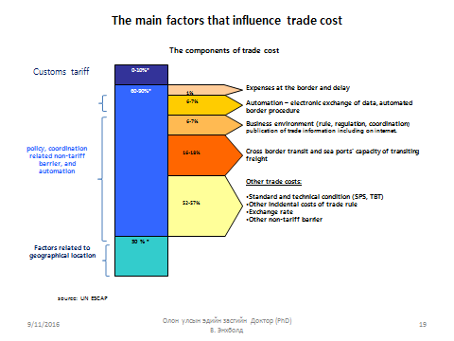
Trade cost performance of a given country varies significantly depending on trading partners, as well as they type of goods traded. Overall, trade costs of many economies of the Asia-Pacific region have decreased, but much remains to be done to address non-tariff barriers (NTBs). Indeed, although ESCAP estimates reveal that many economies of the region have made significant progress in reducing costs over the past decade, they also show that in many cases nearly half the cost reduction may be attributed to tariff cuts. Recent ESCAP’s research suggests that tariff trade costs in Asia and the Pacific generally account for 0 to 10% of bilateral comprehensive trade costs, while other policy-related trade costs (i.e., of a non-tariff nature) account for 60 to 90% of bilateral trade costs (Expenses at the border and delay, Automation – electronic exchange of data, automated border procedure, Business environment (rule, regulation, coordination) publication of trade information including on internet, Cross border transit and sea ports’ capacity of transiting freight, other trade costs such as Standard and technical condition - SPS, TBT). Natural trade costs, such as geographical location vary widely depending on the partner countries considered, but account on average for more than 20% of trade costs. (See Figure 1)
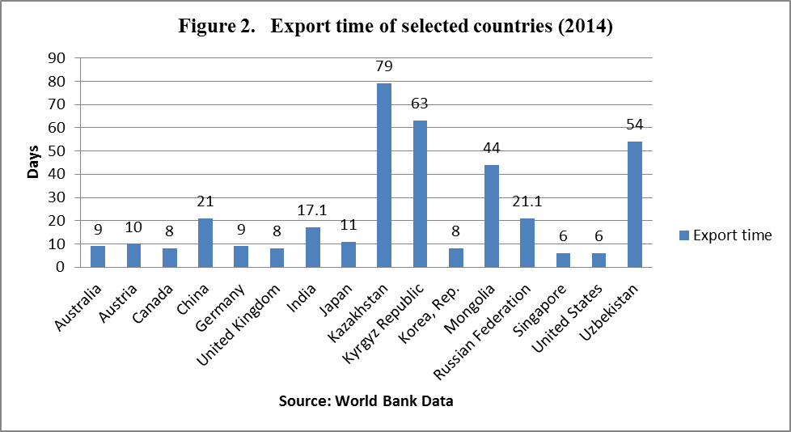

According to the World Bank data, cost to export the container from Ulaanbaatar, Mongolia to sea ports in destination countries. Time and cost to export is the procedures necessary to comply with all procedures required to export goods. Time is recorded in calendar days. Cost is real cost occurred by dispatching the container from exporting country to the destination country. The calculation for a procedure starts from the moment it is initiated and runs until it is completed. Figure 2 explains that Mongolia’s time for export is 44 days 8 while it is 21 days for neighboring Russia and China, 8 days for South Korea and Canada, and only 6 days for Singapore and USA.

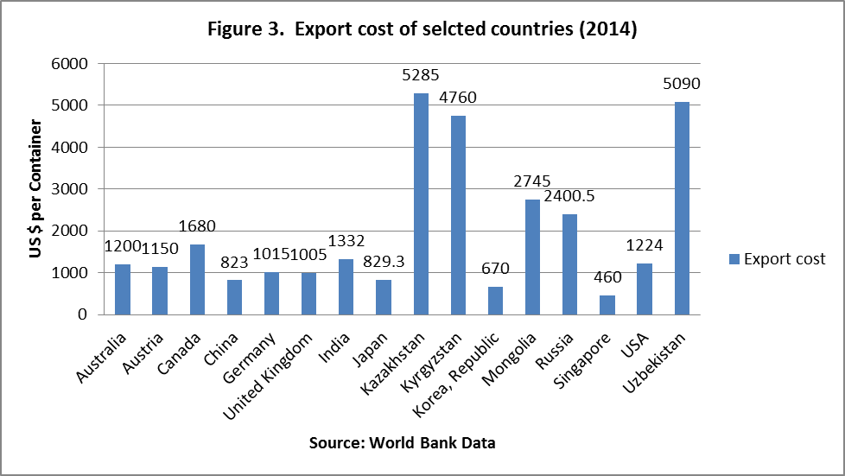
According World Bank data, the costs of exporting 20’ Container to export destinations costs in average 2745 US$ for Land locked Mongolia, while it costs 823 US$ for neighboring China, 670 US$ for South Korea, 829 US $ for Japan etc. That means our major trading partners have much better and cheaper situation than Mongolia for exporting their products to other destinations. On the contrary, export costs are high for double-land locked countries like Kazakhstan and Uzbekistan ranging between 5100-5300 US$, explaining that geographical location is critical for exports. Exporting 20’ container from Singapore costs only 460 US$ means Singapore has become the world shipping hub and deeply facilitated its trade and logistics issues.
Export cost analysis of Mongolian companies: The consultants were assigned to carry out an assessment of the supply chain of imports and exports from Ulan Bator to the Mongolian border points at Zamyn-Uud and Erlian and assess the current trade facilitation arrangements, particularly addressing the processes, procedures and logistics at freight forwarding authorities, transport and logistic institutions as well as customs offices and the facilities at the border points at Zamyn Uud and Erlian. To this end, analysis on the costs of Mongolian export companies were conducted within the assignment and compare the results with the World Bank and UNESCAP findings on trade costs for Mongolia exports. The current analysis has completed based on the surveys interviewed with 4 different Mongolian companies, who are involved in export and import activities. Namely the “Khatan Suikh” company engaged in export of meat and meat products, “Bold Tumur Eruu Gol” company engaged in export of iron ore products, TGI Freight Forwarding company and “Ata Trading Co Ltd” engaged in imports of construction raw materials. Based on the data and information gathered from the surveyed companies, Export product sample testing on a testing laboratory (96 hours), obtaining veterinary certificate for export (6 hours), Customs clearance and freight document (8 hours). UNESCAP survey suggested that Non-tariff barriers take the majority of the costs in trade. This survey coincided with our analysis, because almost %) percent of the time occurred for exports of Mongolian products is for internal and transit non-tariff procedures.

Figure 4. Analysis of export costs of Mongolian companies
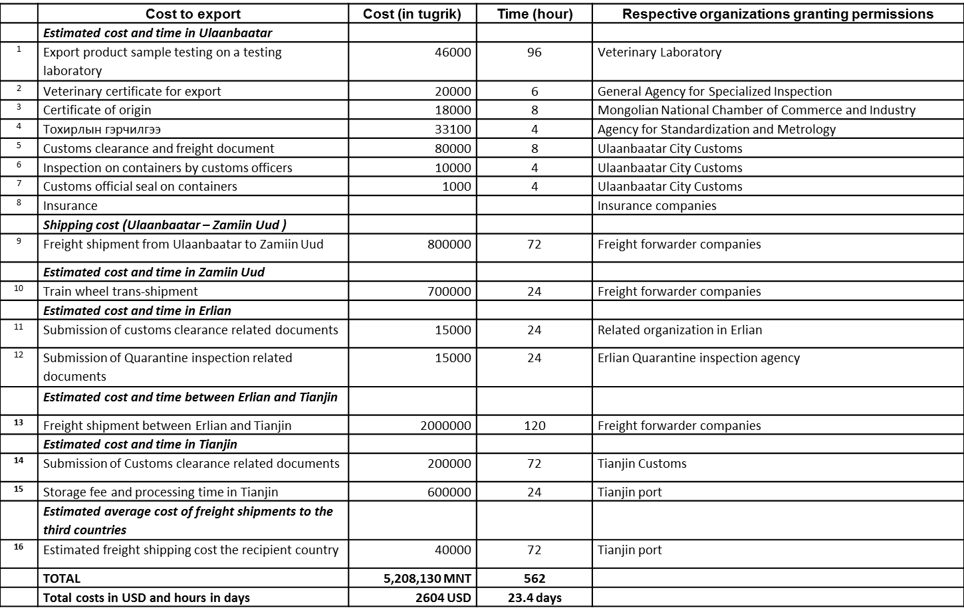
Conclusions:
World Bank / UNESCAP trade costs data explains 44 days for time to export and 2745 US$ for shipping container from Mongolia to destinations. Our costs analysis based on surveys with Mongolian exporters and freight forwarding companies revealed that 23.4 days for time to export and 2604 US $ for costs to export for Mongolian companies. Our export cost analysis for Mongolian companies is almost same as World Bank/ UNESCAP survey, however, time to export is 23.4 days or twice less than World Bank analysis. Perhaps, we have not accurately calculated the time for delays and unseen formalities, means deep analysis and survey covering more exporters need to be conducted to come out with an exact cost.

Most of required formal documents and processing hours on issuance of documents from the Mongolian authorities can be simplified through the introduction of automation system, create easy online registration and introducing online customs clearance. If the simplification of trade documents, automated border procedures, single submission points for all required documents (single windows) are in place for the exporters, approximately 40% (approx 10.3 days) of the cost to export for Mongolia can be reduced. This will have positive impact on export products flows and not only the cost brought down but also number of days of freight transport to the third countries will be reduced by approximately 9 days. For example, export product sample testing on a testing laboratory in veterinary laboratory takes up to 96 hours (4 days), which can be lowered if this process of testing speed up. Customs clearance and freight documents issued by Ulaanbaatar customs cost 80,000 tugrik. All of required documents brought to the single window system; these costs can be lowered as well.

According to UNESCAP studies, approximately 60-70% of the cost components come from non-tariff barriers including bureaucratic approaches on the issuance of export documents. Trade facilitation is the most important for increasing Mongolian export to the third countries. Without solving this issue, Mongolia will witness same negative statistics on our trade in coming years and the agenda of increasing Mongolian export products will be hard to achieve.

Once trade facilitation agreement is ratified by member countries at WTO, concentration on the implementation of this agreement should be the main agenda of Mongolian Authorities. Specially, Article 11 of the agreement highlights the freedom of transit which will allow Mongolian businesses to transport their products to the seaport with more cost effective and faster. Mongolia is required to introduce nation-wide “Single window system” to facilitate and simplify the exporter/import transactions.

Recommendations & Mission Examples to Benefit from Single Window

Institutional and Governance

- A national coordination and cooperation committee is very important for Mongolia to form with proper governance structure and with a legal mandate from the highest level of government. Mongolia could reconstitute their National Trade and Transport Facilitation Committee established in 2009 under the ‘Transit Mongolia’ resolution and action plan. This institutional mechanism needs to contain both government and business officials with working groups such as those already started. The ADB Regional Improvement of Border Services Project has a structure for a Steering Committee and Project Implementation Unit that could be enhanced under international practices. The UNCTAD has a training and certification program available to Mongolia: “UNCTAD Empowerment Program for National Trade Facilitation Committees.” This institution is necessary for the long term and without political change after elections. The success of the Single Window and possible funding from the WTO for their Trade Facilitation depends on this national inter-ministerial and agencies with businesses institution.

- Working Group for Customs needs to include UB Customs since they involve over 50 percent of Mongolia’s trade. Also, need to bridge the gap between Customs and agencies in knowledge and technical skills

- Formalize and disseminate information for joint cross border meetings with Erlian, Inner Mongolia involving business and government and form working groups in connection with the NTTFC toward linking the borders with Tianjin e-Port system. For example, Zamyn-Uud Customs started date exchange in August, 2016 with Erlian and involves Gashin Sukhait border for all goods.

Legal

- Pass a government resolution similar to the 2009 ‘Transit Mongolia’ for establishing a permanent and perpetual NTTFC with working groups meeting quarterly and fund a permanent Secretariat office under the Prime Minister/Cabinet with 2-4 full time permanent staff from business and government charged with coordinating and cooperation among all agencies, setting meetings and moving forward on the Single Window even when governments change.

- Institute a civil service law to ensure that government employees have the incentives to stay on their posts in the interest of the success of the Single Window national initiative. Also, research international practices for creating new jobs for the Internet economy brought on by the Single Window.

- Trade Law-Need to define individual traders and for small and medium enterprises for Customs declarations by identification numbers so that duties collected and can connect to the SW by the Internet. This will also reduce “unofficial fees” from face to face meetings with agencies.

- Implement Laws-Need to complete the instructions for agencies to implement the e-signature and e-stamp process. Implement cross border data exchange agreements for the long term such as the August 2016 for manifests with China and the Tripartite Transit Agreements (Mongolia-PRC-Russia) as well as the access to the China seaports agreement of 2014. Also, need the laws for international product standards under MASM in order to lower costs and delays for exports and imports.

Technical

- The findings of the two weeks of interviews in Mongolia revealed that government and business leaders are not aware of the conceptual and practical purpose of the GoM initiative to implement the Mongolia National Single Electronic Window program. To name of few: Zamyn Uud Customs and the FEZ light industrial factory. As such, a public awareness program is recommended as part of or in addition to similar awareness efforts of the MNCCI. Included in the awareness program can be a manual in summary format of the 2011 MNSW Master Plan as detailed by MCGA, MNCCI with UNESCAP support. A sample can be found in the Annex of this report.

- Inner Mongolia is implementing electronic single window along with a national PRC plan. This includes Manzhouli at the Russia border. There could be lessons learned from these initiatives for the Mongolia SW project.

- Erlian is unifying their systems for cross border processing of Customs, Quarantine and passengers. There are valuable lessons here for Mongolia and also involve Mongolia receiving donated equipment from Erlian.

- Research the international practices of the data architecture required to exchange data with the PRC. For example, the Russia and Mongolia exchange data under the ‘Webnet’ system and the International Railway Cooperation Organization has practices. This could resolve the issues involving Mongolia processing Customs and rail on two separate systems causing delays.

- The MNSW Master Plan recommends a long term objective of connecting MNSW to neighboring countries. However, full benefits could be realized sooner with lessons from the Russia-Mongolia rail platform for documentation and from the PRC starting data exchanges with Mongolia.

- E-Kiosk project implementation could provide useful information and lessons from the Information and Communication Technology Authority for MNSW.

- E-Trans logistics depot started a small single window project as did the Mongolia Railways that could be testing grounds for the MNSW project.

- Mongolia Federation of Freight Forwarders website needs to have English language.

- Need further research for the MNCCI on costs and on line processing in the EU of the country of origin documents.

Mission Examples to Benefit from Single Window

- Zamyn-Uud Free Economic Zone (FEZ), Building Materials Company:

This 100% Mongolian invested business is producing from iron metal raw material imported into the FEZ from China and transforming the metal into building materials sold to the Mongolian construction industry. This company is losing orders by demand from Vietnam customers because the MASM process for conformity certification of their imported machines is slow. MNSW will expedite the process for his license to export
Finished Products in Light Industry Production Site
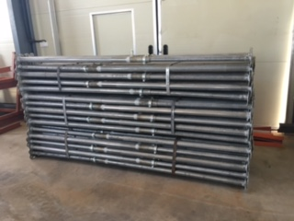

- Wagner Asia Equipment Supplies Mining Sites

Wagner Asia supply chain is importing from Caterpillar sources worldwide by ocean and air and overland to Mongolia mining sites, such as Oyu Tolgoi. Most supplies arrive from the Singapore Caterpillar Regional Distribution Center. Some supplies arrive through Russia from the European Union. The problem is potentially millions of dollars in lost mining production to customers when an OT production shovel (4) costing $25 million each and supported by 7-8 moving trucks ($5 million each) has an emergency part malfunction. The country of origin (CoO) document is processed by the CAT supplier normally in 3-5 days, electronically. The emergency case will require delivery in 48 hours not enough time to process the CoO. The use of the MNSW will greatly improve processing of the CoO, electronically. Moreover, paper based CoO processing is also subject to face to face Customs officials which could not only delay and cost, but also subject the applicant to unofficial fees.
- Zamyn-Uud Customs and Inspection Rail X-Ray

This new X-Ray technology is important to improve processing time at the borders. The before process was physical inspection by hand and manual checks of documents. Now, the X-Ray machine photographs the wagons on the train as they pass through and digital images are saved for electronic transmissions. The benefit is 1 train of wagons is checked by the X-Ray inspection in 3 minutes. The process was one wagon inspected in 4 hours to 2 days. However, the full benefit is not realized until can connect the digital photographs to the CAIS Customs system and by extension the MNSW for national viewing which requires a 6-7 kilometer cable costing 60 million MNT (US$30,000).
Trains moving through the station for X-Ray and Photographs
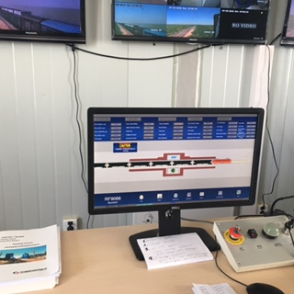

Annex

Annex 1: Sample Manual of the Mongolia National Single Electronic Window Master Plan

Chapter 1: INTRODUCTION
Numerous studies show that Mongolia’s economic development will improve by diversifying its economy across many sectors. In support of that diversification, facilitation and management of trade costs and delays are paramount. Developed and developing economies are embracing new technologies found in desktop computer Web-based and mobile device software applications that move from paper documents to digitized documents (paperless) by automating business processes over Internet connections for business traders (imports/exports), Customs and government agencies. Teams of hardware, software and network engineers are trained and employed to code documents into a paperless international trade environment.
The Single Electronic Window is one part of many to improve Mongolia’s trade regime. Other important components include improved cross border and corridor infrastructures, and cross border and intra-government ministries and agencies coordinating and cooperating within a defined institution(s). As specified in the United Nations Centre for Trade Facilitation and Electronic Business Recommendation Number 33, the single window is a facility that allows parties involved in trade and transport to lodge standardized information and documents with a single entry point to fulfill all import, export, and transit-related regulatory requirements. If information is electronic, then individual data elements should only be submitted once.
The main objective of trade facilitation is to minimize the complexity and reduce the transaction cost of international trade for business while maintaining efficient and effective levels of government control. For government, it can provide increased and correct revenue yields from customs duties, encourage increased compliance by traders, contribute to faster economic development and encourage foreign direct investment. The benefits to traders include fewer delays for shipments, reduced trade costs, a more transparent and a simpler framework within which to conduct business and faster clearance and release of goods through channels that are legitimate and predictable.
1.1 Business Process Analysis (BPA) on Mongolian Key Products
With the support of the United Nations Economic and Social Commission for Asia Pacific (UNESCAP), Mongolia conducted a simplified business process analysis on import and export of a few key products, namely meat export, cashmere export and import of pharmaceutical products in 2009. Review on the processes for exporting cashmere (de-haired) and meat as well as importing pharmaceutical products revealed inefficiencies and bottlenecks in the importing and exporting process and highlight opportunities for trade agencies to reduce the time and by extension, the costs associated with trading these products.
Cashmere Export
Major bottlenecks identified in the area of inspection and certification. By aligning inspection and certification requirements of Mongolia with the importing countries, redundancies can be greatly reduced with the saving of time and cost; it is estimated that 10 -15 days of export time can be saved with improvement in this area. Another finding is the existence of unnecessary documentary requirements that can be removed with the improvement of existing MCGA regulation, which can result in cost savings of 80,000 – 90,000 Tugrugs for obtaining license and 150,000 Tugrugs in laboratory tests.
Meat export
Currently, Mongolian meat is exported to Russia, some neighboring Asian countries and beginning to export to China, but market can be expanded to other countries with the improvement of export processes. Major bottleneck in meat export found to occur in arranging rail transportation due to inefficient operation of services by the UB Railway. Other identified major bottlenecks include inefficiencies in the administration of customs and inspection agencies, duplicate certification by inspection and standard agencies, uncertain inspection fees due to unclear regulation and extensively redundant documentary requirements.
Import of Pharmaceutical Products
Licensing time can be reduced with the revision of regulation from the Ministry of health by accommodating the improvement of information exchange among MCGA, GASI and the Ministry of Health. Another area of improvement is duplicate administration of documentary requirement and examination by customs, standard and inspection agencies. It was also noted that inspection agencies need to improve human capacity in the service administration to speed up the delivery of products to market.

1.2 What Single Window Can Do
A Single Window is a one-stop facility to exchange information between traders and government agencies, thereby reducing the complexity, time and costs involved in international trade. It can bring benefits both to traders and government agencies as described below.
Table 1-3: Benefits of a Single Window
Benefits for government agencies | Benefits for traders
- More effective and efficient deployment of resources  - Correct (and often increased) revenue yield  - Improved trader compliance  - Enhanced security  - Increased integrity and transparency | - Cutting costs through reducing delays  - Faster clearance and release  - Predictable application and explanation of rules  - More effective and efficient deployment of resources  - Increased transparency
Source: UN/CEFACT Recommendation 33 on Single Window
According to the findings of the Mongolia BPA, bottlenecks and problems are mainly identified in the areas of duplicate documentary requirements, inefficient and redundant regulatory administration by government agencies, lack of automation and transparency. These issues can be significantly addressed with the implementation of a Single Window. Therefore, implementing a Single Window has high relevance to Mongolia in its efforts to diversify the export structure and improve Mongolia’s trade competitiveness.

CHAPTER 2: ASSESSMENT OF MONGOLIA’S SINGLE WINDOW READINESS

2.1 Requirements for Single Window Implementation and Mongolia’s Readiness
Establishing a successful Single Window depends on the enabling political, institutional, legal and technological environment. Strong political commitment, preferably in the context of a strategic mandate combined with a high-level champion, is crucial. Having political commitment embedded in a strategic mandate would ensure continuous support for the Single Window all the way to its completion in a timely manner. Establishing a Single Window also requires proper institutional arrangements, which include the appointment of a lead agency, a platform for stakeholder coordination and operational setting. In addition, relevant laws and regulations should be in place to support the establishment and full operation of a Single Window. Finally, there should be a threshold level of information and communication technology infrastructure to ensure its proper operation and utilization by relevant stakeholders.
At the foreign trade policy level, Mongolia has signed a number of major international conventions which address the streamlining and harmonization of border procedures and the improvement of transit systems with neighboring countries. It adopted the World Customs Organization’s Revised Kyoto Convention on the Simplification and Harmonization of Customs Procedures on June 30, 2006 and started implementation on October 1, 2006. It has also adopted the harmonized commodity description and coding system nomenclature, otherwise known as the harmonized system nomenclature, which is widely used for the classification of all products imported into and exported from the country. The country is party to the Convention on Temporary Admission, which includes Annexes on temporary admission papers, or ATA Carnets. The process for Mongolia’s accession to the Asia-Pacific Trade Agreement (APTA) was formally launched in December 2009.

2.1.2 Institutional Arrangement

The institutions and their governance on a long term and day to day operations are very important to the success of the implementation of the national single electronic window program. The following are necessary institutions and stakeholders:
National Committee on Trade and Transport Facilitation (NCTTF)
The Mongolian National Committee on Trade and Transport Facilitation (NCTTF) is the official coordinating committee for trade facilitation and by extension a Single Window. It is expected to meet quarterly and has responsibility for trade and transportation policy.
Single Window Working Group
The Single Window Working Group, lead by the MCGA and MNCCI, is a subset of the NCTTF. The Working Group has developed a comprehensive action plan and work plan to support the development of a Single Window. The Single Window Working Group has certain level of overlapping membership with the National Committee on Trade and Transport Facilitation (NCTTF).
Transport and Logistics Council
The Transport and Logistics Council is established under the auspices of the MNCCI, with the aim of improving collaboration and providing a forum for the private sector to provide inputs into the trade logistics and transportation discussions. It is made up of 22 representatives of public and private sector entities in the transport and logistics sectors including public and private sectors such as MRTCUD, MFAT, MCGA, NARTAM, Association of Freight Forwarders, Mongolian Logistics Association, Tuushin Co.ltd, Mongolian Railway, Mongol Express, DHL, among others.
Stakeholders
Mongolian Customs General Administration (MCGA) and Customs Automated Information System (CAIS) E-Customs Portal refers to the information service system whose objective is to provide various services through a single electronic window connecting customs administration related businesses such as application, declaration and civil petition in a web-based environment. It supports business of customs administration staff and cooperation and collaboration among customs administration related parties. It also provide service and information necessary for civil petition applicants and related agencies.
- Mongolian National Chamber of Commerce and Industry (MNCCI)
- Information, Communication Technology and Post Authority (ICTPA)
- Ministry of Health (MOH)
- Customs Brokers Association
- Mongolia Taxation General Agency (MTGA)
- Transport and Logistics Providers
- State Specialized Inspection Agency (SSIA)
- Mongolian Agency for Standardization and Metrology (MASM)
- Ministry of Food, Agriculture and Light Industry
- Ministry of Road, Transport, Construction and Urban Development

Chapter 3: Mongolia Single Window (MNSW) IMPLEMENTATION Plan

3.1 Concept of MNSW Operation

3.1.1 MNSW Overview
MNSW is a single-point web portal for the entry of trade related documents, such as customs declaration, license, permits, manifest, invoice, etc., to achieve a number of transactions to be completed with the Government. The National electronic Single Window is to be established with the participation of all the organizations involved in international trade based on the following structural model shown in Figure 3-1. Figure 3-2 also shows a simple operational model of the MNSW. Total of 15 government agencies and 2 private sector organizations are to participate in the MNSW and to be connected to electronic Single Windows of foreign countries.
Using the Web portal of the MNSW, participating foreign traders enter their own required information and obtain the documents they need from other government organizations. The MNSW provides an electronic single point for fulfilling customs clearance.
Figure 3-1: Structural Model of MNSW

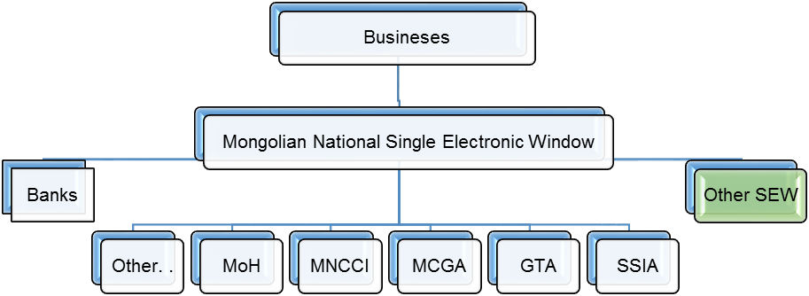

3.1.2.1 Services

Mainly, there are 18 independent services in MNSW for traders and government agencies, which include collecting data, license processing, payment of tax and fees, declaration of import, export and manifest documents through the Internet

Project Administration and Long-term Strategy

3.2.1 Introduction
The implementation of Mongolian National Single Window is a strategic national project, requiring extensive coordination of domestic stakeholders and close cooperation with overseas entities. For its success, the project will be administered properly with the commitment of both public and private sectors. In addition, considering the nature of Single Window needing iterative processes and overtime evolution of its services, long-term strategy will be envisioned from the planning stage.

The MNSW project will be implemented under the overall direction of Prime Minister of Mongolia. For actual implementation, an organizational arrangement will be made at various levels, from steering committee to working groups with specific tasks. The MNSW project will be implemented on the basis of Public Private Partnership; MCGA and MNCCI will play major steering roles as Secretariats on behalf of public and private sectors respectively.
Table 3-2: Exemplary Actions in e-Licensing Process
Functions | Actions
System Registration | - User registers to system and conclude a treaty  - OGA registers and to conclude a treaty
User | - Fill out web form to request license.  - Check the request form in client computer and server.  - Authorize user and message.  - Check and accept user’s license request. Post in license request list.  - If license request accepted by Government agency, then put this license in accepted license list.  - Pay license fee.
Government Agency | - Manage acceptance license list, permit a license.  - Get a new license request.  - Authorize user’s digital signature* and license request.  - System manage accepted license to OGA, license sent automatically.
* All critical documents created in MNSW system are digitally signed. User’s digital certificate is used to sign the data.

3.2.2 Organization Structure for the MNSW Implementation
Figure 3-7 shows overall organizational structure for the implementation of MNSW. At the top, the Prime Minister of Mongolia will guide the implementation with strong government commitment as the chair of the Steering Committee as well as the head of the government Cabinet. For strategic and policy-level decision-making, the Steering Committee is to play the management role. Under the steering committee, several working groups will be in charge of implementation activities and conduct tasks in specific areas. Specific roles and activities of the organization are described in the following respective sub-sections.

3.2.2.1 MNSW Steering Committee

The MNSW Steering Committee is a consensus-based decision-making body in the implementation of the MNSW. The MNSW Steering Committee will conduct its delegated tasks and activities under the guidance of the government Cabinet. As the decision-making body, the MNSW Steering Committee shall be represented by all the major stakeholders at the high-level management from both public and private sectors. Table 3-3 lists the membership of the MNSW Steering Committee

3.2.2.2 MNSW Working Groups
Under the supervision of the Steering Committee, the Working Groups will be in charge of handling specific technical issues. Four Working Groups (WGs) will be established under the Steering Committee; they are Business Process and Data Harmonization WG, Technology WG, Training and Communication WG and Legal and International Liaison WG. Though these four WGs work in their particular specialty areas respectively, their works will be closely coordinated since they are interrelated and their works are supplementary one another. The Steering Committee will coordinate the activities of four WGs and may convene a joint meeting among two or more working groups.

3.2.2.3 Administrative Support
In implementing the MNSW, a variety of administrative support are readily required. Such administrative support includes organizing and maintaining the meetings of the Steering Committee and various working groups, communicating with stakeholders, organizing promotional activities, interacting with international organizations and donors, etc. Administrative support throughout the implementation of MNSW will be jointly provided by MCGA and MNCCI as the Secretariat of the MNSW implementation. Specifically, Statistics and Analysis Division of MGCA and Barcode and Logistics Division of MNCCI will be assigned with the duties of secretaries.

3.3 Training
In implementing a Single Window, one of the most important issues for the smooth transition is provision of proper training to all the stakeholders from public and privates sectors. Because implementation of a Single Window requires stakeholders to change their way of doing trade practices, they need to become fully aware of how to do their businesses in accordance with the new practices. The participating government agencies should be aware of how the services they have control over are integrated into or interfaced with a Single Window. Traders should also become fully familiar with the usage of a Single Window facility.
The Training and Communication Working Group (TCWG) under the MNSW Steering Committee will be in charge of assessing the training needs, designing training programs and delivering training in line with the implementation schedule of the MNSW, particularly in close cooperation with the Secretariat.

3.4 Communication
Another important issue for the smooth transition in implementing a Single Window is regular and proper communication with the stakeholders. Communication provides stakeholders with chances to understand what changes are to be made and allows them to prepare themselves to adapt to new practices.

For primary stakeholders of MNSW implementation, organizational structure (various groups and working groups) under the MNSW Steering Committee will provide a platform for communication among themselves. For the general stakeholders and public, the Training and Communication Working Group (TCWG) under the MNSW Steering Committee will design various communication programs such as regular seminar/conference, workshops, e-newsletter, group email list, etc., particularly in close cooperation with the Secretariat

CHAPTER 4: ACTION PLAN - FROM PLANNING TO IMPLEMENTATION

4.1. MNSW Implementation as Pillar of Mongolia’s Business Environment Reform Programme

4.1.1. Vision
The vision of MNSW implementation is to establish a single window for foreign trade facilitation where all import, export and transit-related documents and information are lodged with a single entry point. Such a single entry point would allow single electronic submission and processing of documentation and issuance of e-permit, e-license, e-certificate by trade-related government and private authorities for business community involved in trade, transport, storage and financial services, resulting in the transformation of Mongolian business environment into a globally competitive one.

  - Asian Development Bank: Proposed Loan Mongolia: Regional Improvement of Border Services Project

At present, funding resources are approved and some already deployed for key trade logistics infrastructure projects that were on the drawing board since 2008 under the ‘Transit Mongolia’ resolution and action plan of 2009. These include not only preparation for Mongolia’s National Single Window under the ADB Regional Improvement of Border Services Project, but also the ADB project under construction of the Zamyn Uud Logistics Center and ADB completed connecting roads along the Ulaanbaatar to Zamyn Uud corridor and ADB assistance for Customs modernization. All of these initiatives completed, under construction and proposed will measurably lower the import and export costs and delays for increased business profits, more government revenues and attract more foreign direct investment to spur diversified economic growth.

The ADB loan proposal of $29.07 million has approval from the Government of Mongolia for the following:
- Facilities and equipment at Altanbulag, Bichigt, and Zamyn-Uud border crossing points are upgraded and improved
- Communication infrastructure for Customs Administration Information System is improved and General Administration of Customs and Tax systems are interoperable.
- Preparatory work for single window is undertaken.
- A revised single window model will be prepared for key trade-related agencies (GACT, General Agency for Specialized Inspection, Veterinary and Animal Breeding Agency, Chamber of Commerce and Office of Immigration).
- Agreement among agencies to link information systems, information sharing and current documentary requirements for all agencies will be streamlined then agreed set of documents needed to clear cargo under the World Customs Organization Data Model
- Implementation arrangements will also involve the following:
- Ministry of Finance as the executing agency.
- The GACT will be the implementing agency.
- Project Steering Committee will be chaired by the Ministry of Finance and composed of senior officials of the Ministry of Finance, GACT, Cabinet Secretariat, General Agency for Specialized Inspection, Veterinary and Animal Breeding Agency, Office of Immigration and the MNCCI. The steering committee will meet quarterly for budgets, progress, guidance, and coordinate between ministries and agencies involved in project implementation.
- Project Implementing Unit established in GACT for day-to-day management of the project.

The purpose of this draft sample manual is for dissemination in the public awareness program recommendation of this report. Many business and government officials during this mission had very little or no knowledge of the Mongolia single window program. Key information is from the “Mongolia Single Window (MNSW) Implementation Master Plan,” draft version 0.98, January 5, 2011, prepared by Mongolia (MCGA and MNCCI) with the support of UNESCAP (124 pages), and from the ADB Report and Recommendations of the President to the Board of Directors, Project Number: 47174-001, April, 2016, “Proposed Loan Mongolia: Regional Improvement of Border Services Project, and from this consultant’s knowledge.

Annex 2: Meeting documentation

Ulan Baatar, Zamyn Uud Mongolia and Erlian, Inner Mongolia, PR China Meetings from July 18-28, 2016
Robert L. Wallack, GIZ/EU International Consultant, U.S.A. for Economic Governance for Equitable Growth (EG4EG)
Dr. Enkhbold V., National Consultant Mongolia

Study Tour and Analysis on the Supply Chain and Recommendations for Facilitating a Mongolia Single Electronic Window

Person/Title | Office | Date | Summary of Meeting Notes (70 pages)
1.) Greg McTaggart, Mr. Enkhbold L. | UB Hotel lobby/lunch | July 18 11:30-4:00  To 5:30 for calling Erlian hotel | By phone at lunch called Mr. Xilibaatar in Mongolian and he requested letter from office of purpose, dates of visit, etc. Erlian hotel reservation needed for PRC visa.
2.) Greg, Enkhbold L and Enkhbold V. | 8:30-9:45 apartment;  11:00 office | July 19 | Asked Stoyanka for Tianjin docs; Asked Greg for Erlian letter set work plan. Met with Enkbold L and Enkbhold V to review 2009 Transit Mongolia document for IT. Unur drafted letter to Erlian. After MNCCI meeting 6-6:30 in GIZ office to edit letter
3.) Ms. Sharbandi Tsevelsaikhan, Head  Ms. Tsetsegmaa Chuluunbat, Director Export Promotion | Mongolia National Chamber of Commerce and Industry | July 19 3:30-5:15 | Excellent background and update of Mongolia SEW Program. Highlight: ADB $27 m. loan for MNSW.
4.) Ms. Battsengel G. Head Information and Training Center and Mr. Erkebulan Seser, IT Specialist | Mongolian Agency for Standardization and Metrology | July 20 5:00-6:00 | Excellent information and functions of MASM www.SMMSS.eu Discussed problems of budget, e-signature, e-security, conformity certification, IT infrastructure in Mongolia, lack of staff, costs for SW, etc.
5.) Ms. Oyun Tsogtsaikhan, Director IT Mr. Badamsuren Byambaakhuu, DpDir  Mr. Battsengel Sodnom, IT Dpt | Information Technology, Post and Telecommunications Authority | July 21 11:15-12 | Discussed SEW problems in Mongolia:  Change of government, staff, weak cooperation among organizations, their e-government plans: e-Kiosk, ADB lead on SW Working Groups. Follow up on e-gov.
6.) Mr. Batkhuyag Purev, Head | UBTZ UB Railway  IFFC | July 21 2:15-3:00 | PRC not electronic but phone and not good. Problems with transloading and slow documents. Better advance data with Russia on Webnet system. Gave data on Russ/PRC
7.) D. Jigjidnyamaa, Dp. Chairman and 12 others: M. Sukhbaatar, Enkbold, M. Rail N/W, Russian-Mong Coop Dpt, China/Mong cooperation Dpt, Nasanbat, FASCO FF co, Mr. Ganzorig Bayarsaikhan, CEO | Mongolian Railway Authority, Boldtumur Eruu Gol Co, mining,  Federation of Mongolian Freight Forwarding | 3:00-4:15 | Excellent presentation and conveyance of information on rail, and new freight forwarding organization in Mongolia. Need legal environment for FFs in Mongolia. Need lead agency to implement SW in Mongolia. Need money. No new UB container yards in last 5 years.
8.) Mr. Bekhbat Damdinsuren, Dp Chm | Mongolia General Customs & Tax | July 22 10-10:20 | ADB Government approved loan. Use CAIS, Working Groups ready, need national committee, involve border agencies
9.) Mr. Enkhtaivan Gelegjamts, Head UB Customs House and Mr. Nemda, IT | MGACT | 1:30-2:30 | Customs and Tax to separate again will slow SW progress. SW working group set up with pilot tests in Zamyn Ud. Technical gap between Customs and agencies. UB Customs has 60-70% of national customs. Gen customs has policies/UB implements. Need trade law to define traders since violators now and need to connect to SW, legally declare goods. Need training. Visited modern UB Customs office.
10.) Ms. Lkhagvasuren | UB Customs | July 24-25 on Train | Discussed Country of Origin not known in Mongolia and are there costs? Need to convince traders/government on SW, TIR on paper and without, Apply Russia-Mongolia electronic to PRC-MON. She asked UB Customs to provide details.
11.) Mr. Tsogtbaatar Oktyabyri, Director | Zamiin Uud Customs | July 25 1:00-2:00 | Knows little about MNSW. Needs training and master plan summary. Need national committee to implement SW. Will have data exchange with PRC in August, 2016. Have new X-Ray, ADB ZU Logistics facility by 2018 and FEZ ready and started light industry production. He provided excellent access to driver and tour of ZU.
12.) Ms. Tekhtsetseg, Officer  Mr. D. Nyantsogt, Officer  Factory Owner and Bookeeper, Ms. Tmoonjig | ZU Customs and Factory producer of metal products for construction customers | July 25 2:00-2:30 | Tour and narrative on ZU Free Economic Zone: 10 + companies set up, all infrastructure underground is completed. Factory has no MNSW information and needs SW since losing exports to Vietnam b/c MASM slow to approve conformity certification/license. Photos taken
13.) Mr. Nyantsogt | ZU Rail X-Ray Facility | 2:30-3:00 | X-Ray machine technology in office is paperless and vastly improves over paper documents. Took photos. Need 60 m. MNT to connect to Customs CAIS. Took photos
14.) Mr. Nyantsogt | ZU Logistics Center by ADB | 3:00-3:30 | Will complete in 2018 for truck and rail transshipment center. Took photos.
15.) Mr. Enkhbold | E-Trans Logistics Center | 3:30-4:00 | Little information on SW. Have one stop center with computers to serve all traders. Their customers benefit from their services.
16.) | Arrival in Erlian | July 26 in afternoon | Customs meeting at 11 cancelled
17.) Mr. Ma Si, Officer | Erlian Government | July 27 11:00 | Discussed purpose. Mr. Xilibaatar did not set up any meetings and did not connect with us to assist.
18.) Erlian Mongolia Consulate  Mr. Li Hai, officer | Car tour of Erlian Border logistics, etc  Erlian government | 2:30-3:30  8:00 pm | Have Agriculture bonded warehouse with refrigeration. (Mongolian export meat?)  Met in Hotel to assist us in setting up border administration meetings.
19.) Mr. Su He | Former Erlian government official | July 28 11:00 | Set up afternoon meetings and described mission purpose: MNSW & supply chain.
20.) Mr. Khanbat, Chief Erlian Customs; Mr. Ulzii, Deputy Chief  Mr. Burged, Officer Customs  Mr. Davshil, Officer Inspection and Quarantine Zone, Erlian | Erlian Border Administration | 3:30-5:00 | Gave 5 questions to translators to prepare.  Excellent meeting to provide background on Erlian road and rail border transport. Combining processes: Customs, inspections, persons on one stop system. Steps to become electronic. Discuss donating equipment to ZU. Implementing China single window within IMAR. Gave data on cross border, information on cross border meetings. PRC quarantine licenses are electronic. PRC traders need Mongolia CoO requirements.
21.) Mr. Nan, General Manager | Sinotrans | 5:00-6:00 | Single window in the works and saves for traders in PRC. Gave cross border stats and information on cross border business-government meetings.

Annex 3: Workshop documentation: “Trade facilitation: “TRADE COSTS ANDE-SINGLE WINDOW SYSTEM”, August 9, 2016

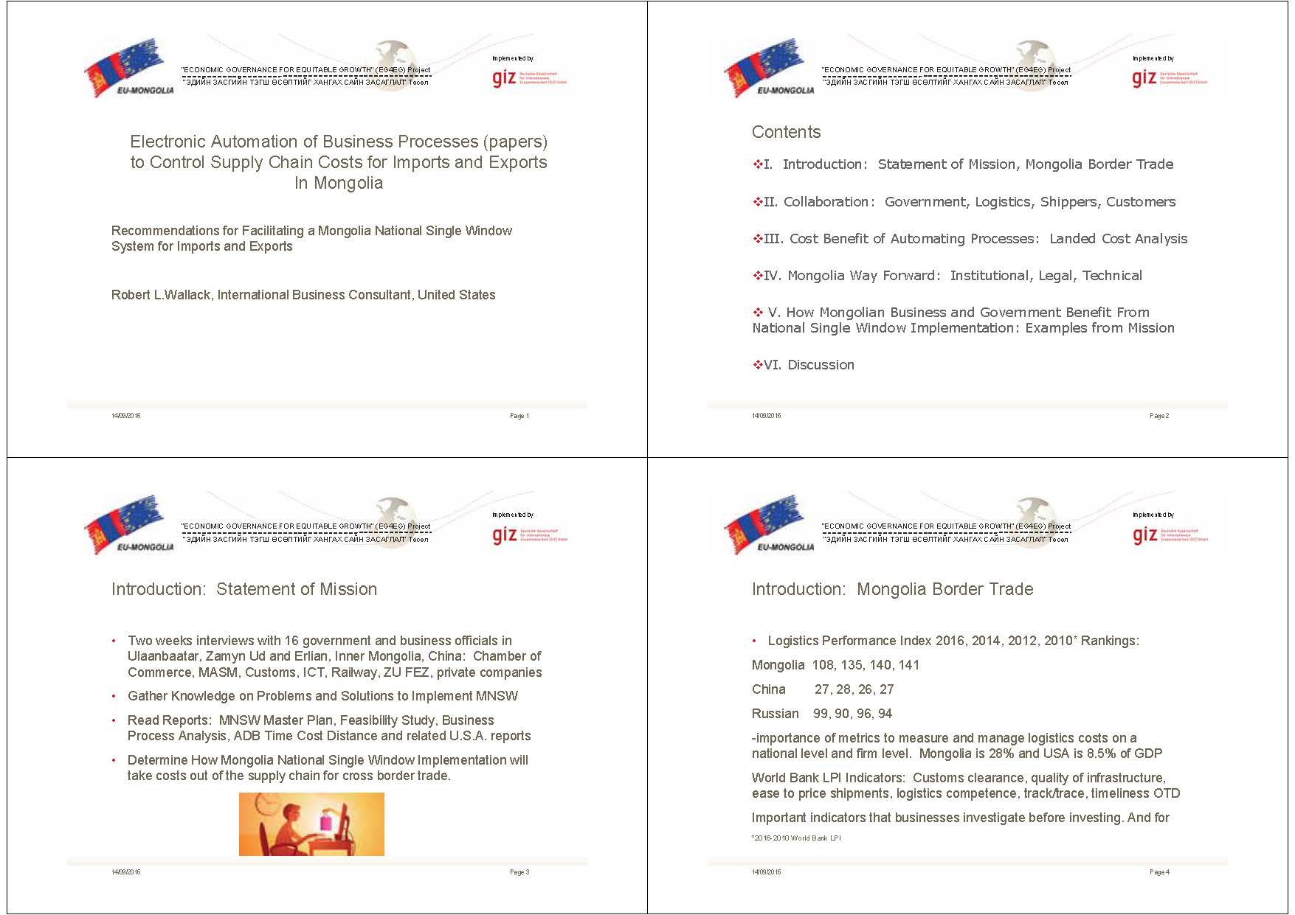
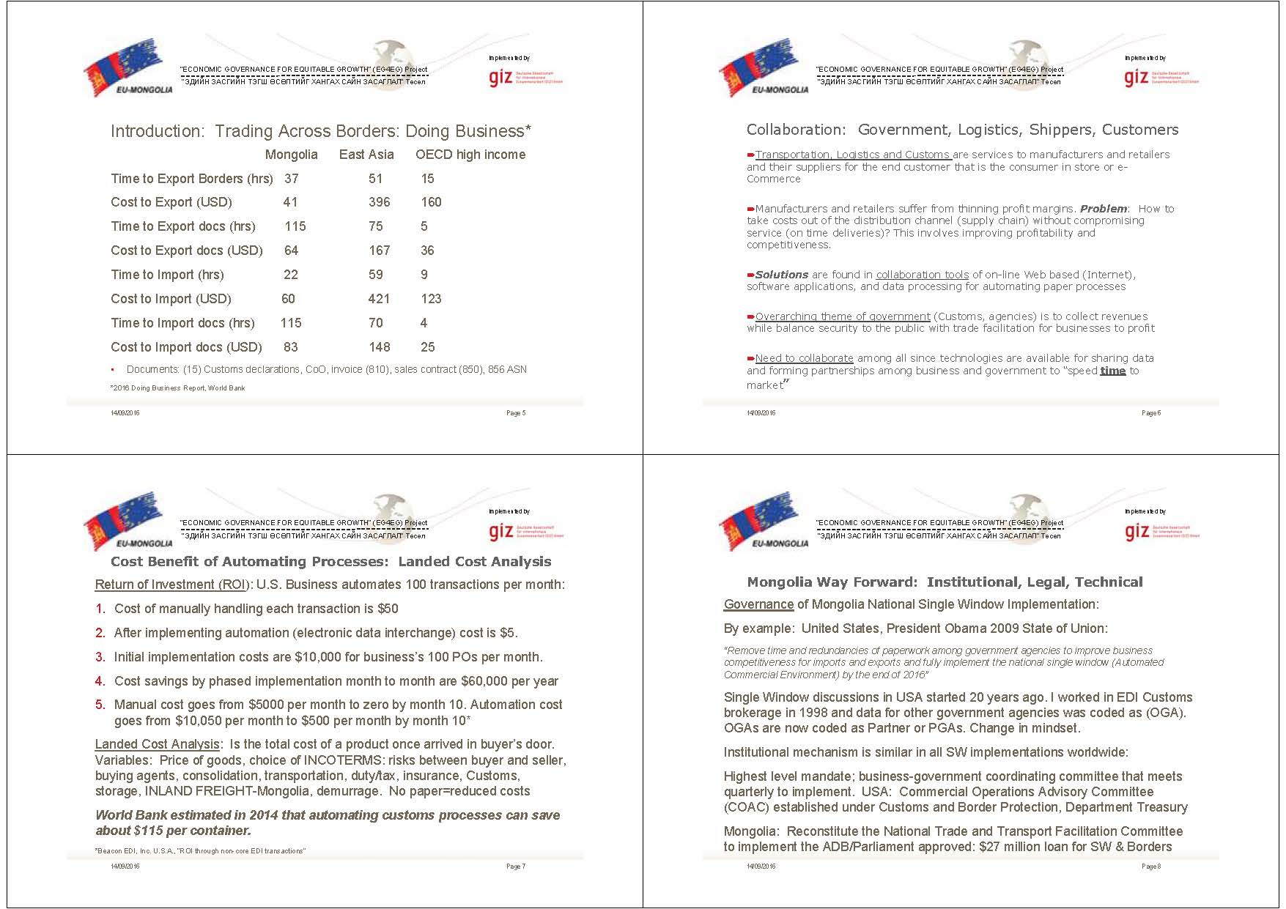
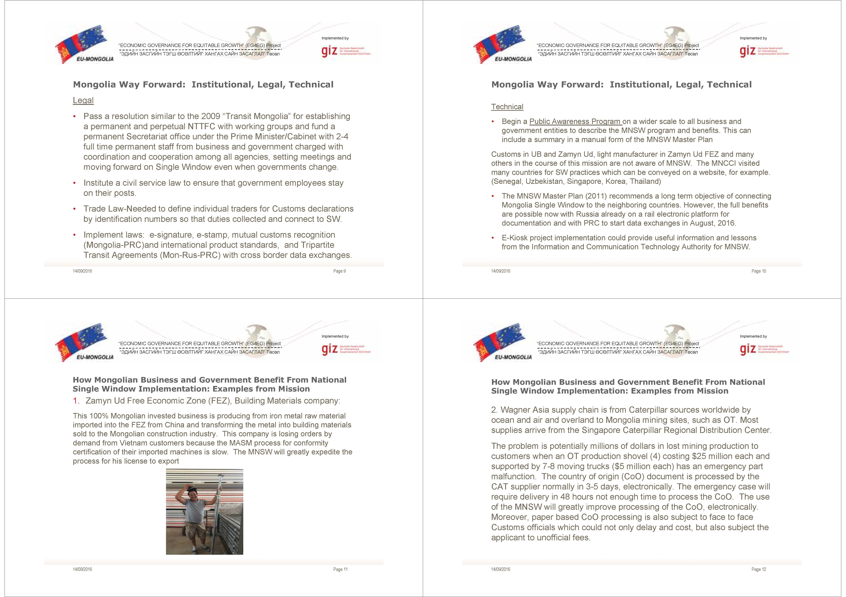
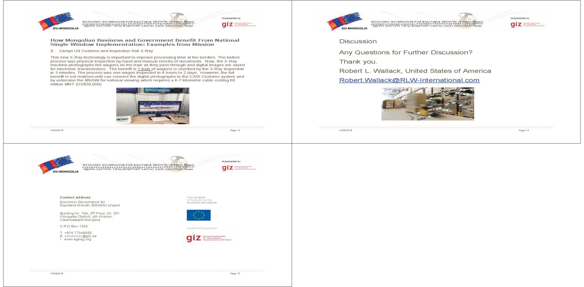
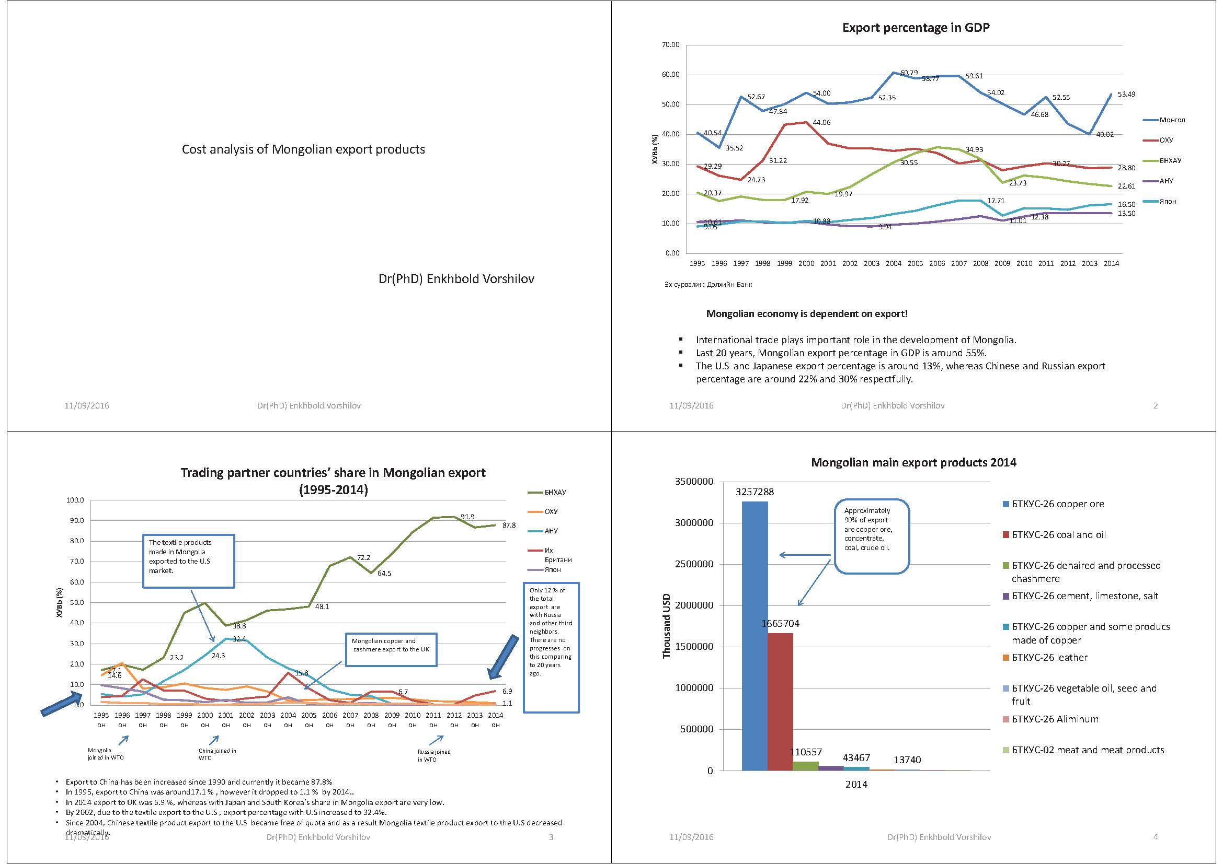
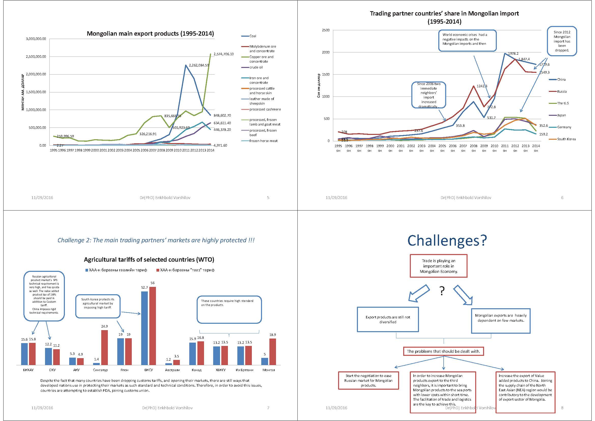
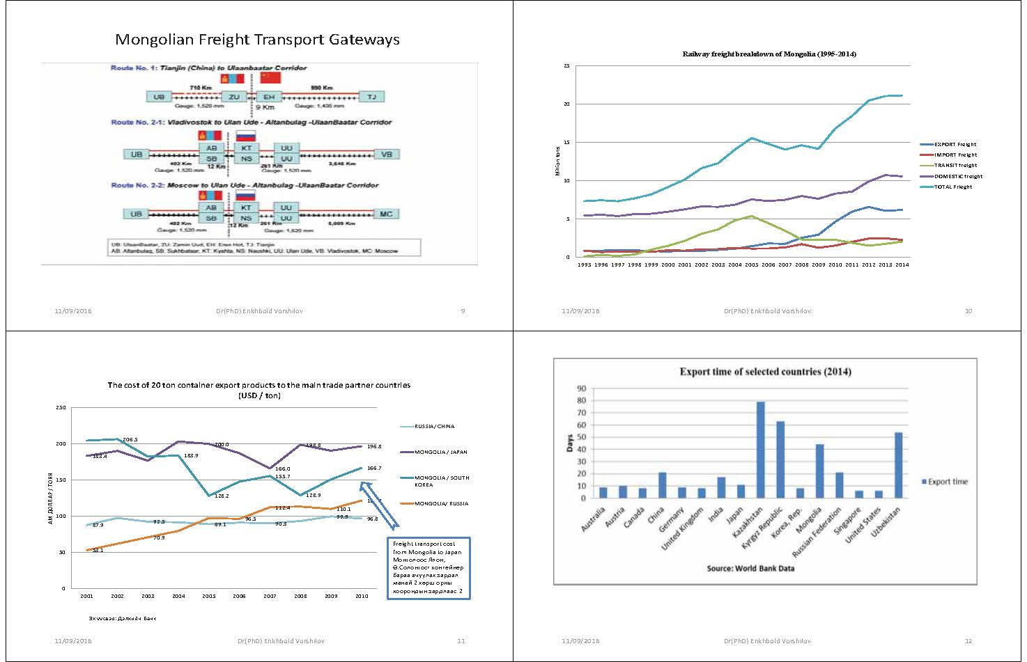
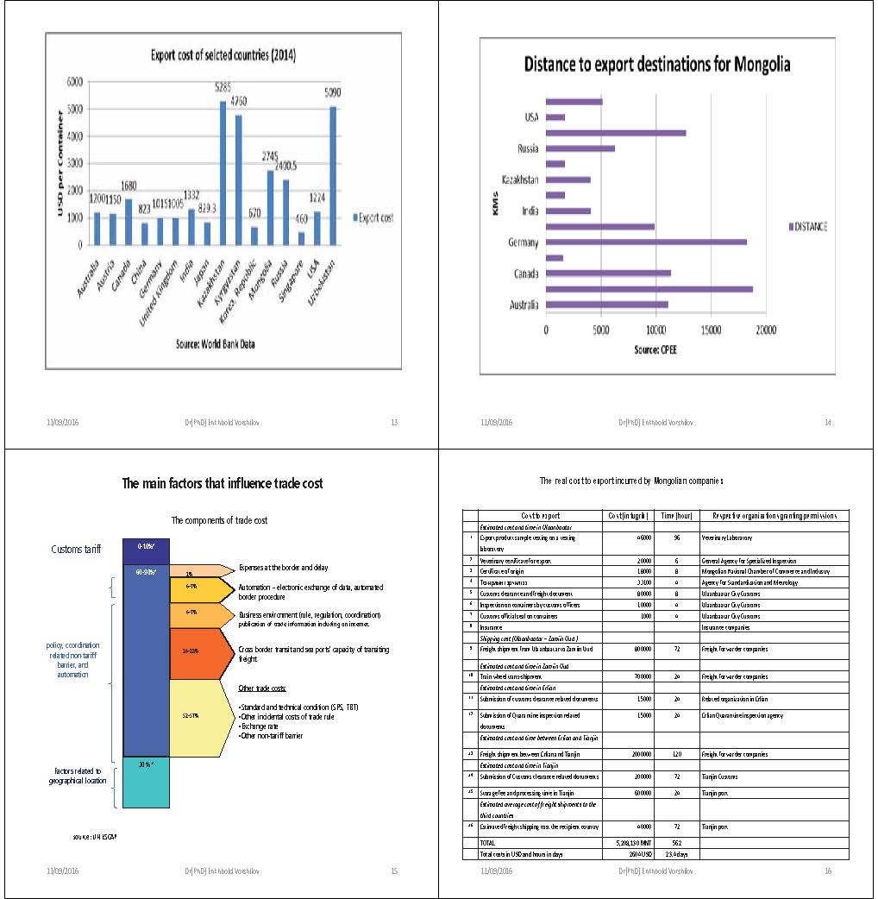
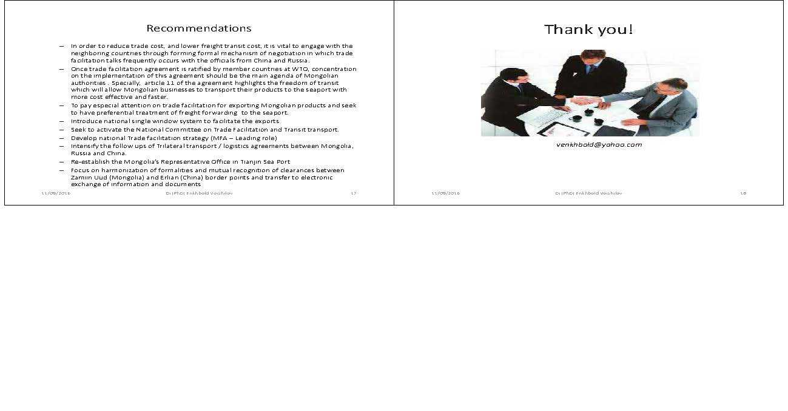
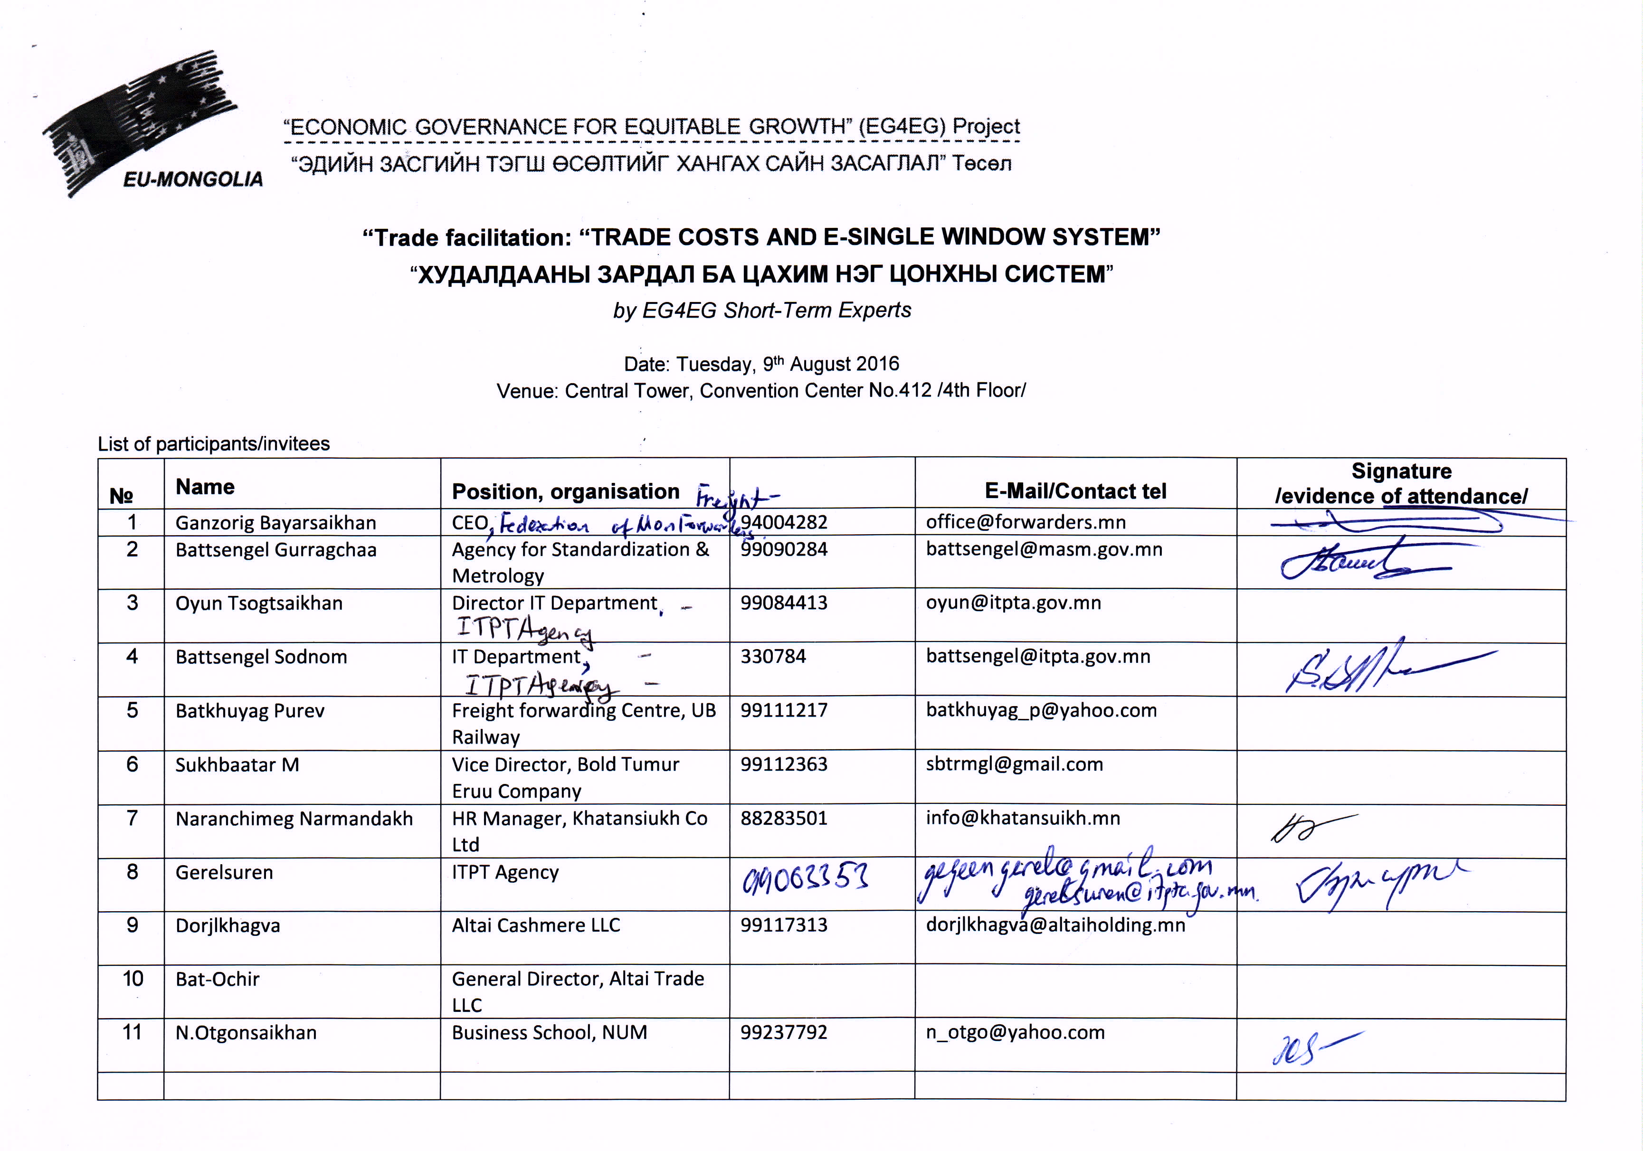
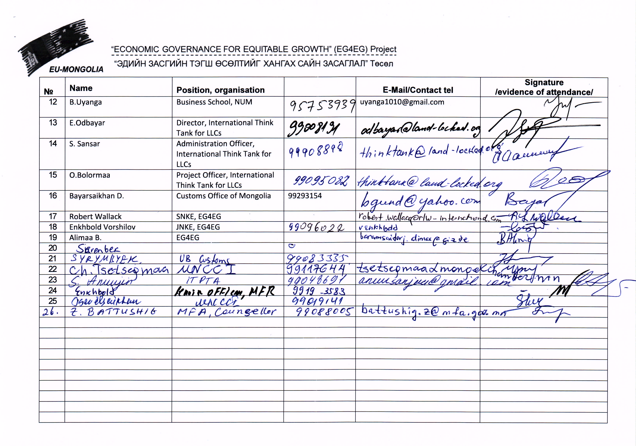

Contact address:

Economic Governance for Equitable Growth (EG4EG) project

Bldg. 10А, 2nd Floor,No. 201
Chingeltei District, 4th Khoroo
Ulaanbaatar, Mongolia

Central PO, Box-1264

Tel: +976 77348050
Email: delger.unur@giz.de
Web: www.eg4eg.org

Trade Policy Review Body, World Trade Organization. 2014. World Trade Organization Trade Policy Review: Report by Mongolia. Geneva.
“D. Erdenebat: Wool and Cashmere Value Added Export can Increase the Earnings up to One Trillion Tugrugs,” www.Assa.mn, Mongolian Airlines, July/August, p. 18
“ Mongolian Husbandry and Farming, History and Prospects,” Mongolica, Summer, 2016, p. 66
Report and Recommendations of the President to the Board of Directors, Project Number: 47174-001, April, 2016. Project Loan Mongolia: Regional Improvement of Border Services Project, Asian Development Bank, p.1
Output 1: Facilities and equipment at Altanbulag, Bichigt, and Zamyn-Uud Border Crossing Points are upgraded and improved. Output 2: Communication infrastructure for CAIS is improved and GACT systems are interoperable. Output 3: Preparatory work for single window is undertaken.
Central Asia Regional Economic Cooperation Trade Facilitation, Corridor Performance Measurement and Monitoring, Annual Report 2015, Asian Development Bank, p. vii. CPMM findings and conclusions are reported quarterly and annually and found on: www.cfcfa.net.
“China’s Accession to the United Nations TIR Convention Opens Prospects for New International Trade Routes,”UNECE Press Release, July 26, 2016
Beacon EDI, Inc., “ROI through non-core EDI transactions”
Consultant’s recent conversations with senior World Bank trade and transport official
http://unctad.org/tf
Misovicova Maria et al : ESCAP Trade Facilitation in Selected Landlocked Countries in Asia (2006)

